Identifying the Common Components of Membrane Fusion Machines

Beth Graham

Berger Lab

Animal Biology Graduate Group

Department of Animal Science

University of California, Davis

Table of Contents

ABSTRACT 4

INTRODUCTION 4

Steps of Lipid Bilayer Fusion 5

Preliminary Steps 5

Step 1: Loose tethering 6

Step 2: Tight docking 7

Step 3: Hemifusion 8

Step 4: Fusion 9

Step 5: Fusion pore expansion 9

MEMBRANE FUSION MACHINE 10

Fusogen 12

Role 12

Examples 12

Molecular tether 17

Role 17

Examples 17

Fusion regulator 20

Role 20

Examples 21

Frame 23

Role 23

Examples 23

Complex organizer 26

Role 26

Examples 26

Curvature generator 30

Role 30

Examples 31

CONCLUSION 37

FIGURES 39

Figure 1. Steps of membrane fusion. 39

Figure 2. Lipid mixing and content mixing. 40

Figure 3. Membrane fusion machine. 40

Figure 4. Influenza A and hemagglutinin. 41

Figure 5: Atlastin and endoplasmic reticulum fusion. 42

Figure 6: The FAST proteins: simple fusogens. 43

Figure 7. Synaptic vesicle fusion. 44

Figure 8. Myoblast fusion. 45

Figure 9. Complex organizer schematic. 46

Figure 10. Membrane curvature generator. 47

SUPPLEMENTAL FIGURES 48

Supplemental Figure 2. Spontaneous curvature. 49

Supplemental Figure 3. HOPS complex. 50

Supplemental Figure 4. Mammalian fertilization. 51

Supplemental Figure 5. Tetraspanins. 52

Supplemental Figure 6: VAB-10A as a complex organizer in C. elegans. 53

WORKS CITED 54

Identifying the Common Components of Membrane Fusion Machines

# ABSTRACT

All membrane fusion processes must overcome the same set of energetic barriers to lipid bilayer fusion in the same chronological order. All known processes employ protein machinery to overcome these barriers. Although the proteins that mediate membrane fusion differ, the roles played by those proteins repeatedly recur. In this review, we describe seven functional modules of a generic membrane fusion machine: fusogen, molecular tether, fusion regulator, complex organizer, frame, and curvature generator. Each functional module may consist of a protein domain, protein, or multiprotein complex. The purpose of this model is to aid in the identification of proteins involved in membrane fusion.

# INTRODUCTION

Despite their biological importance, many membrane fusion processes – especially cell-cell fusion processes – remain poorly understood. This is due in part to the scale of the puzzle. As membrane fusion is an evolutionary ancient process, it spans the entire tree of life, affecting diverse organisms, tissues, cells, and organelles. As our understanding of individual membrane fusion processes has grown, however, so has our grasp of the fundamental commonalities among them. All known biological membrane fusion processes employ protein machinery to overcome the same set of energetic barriers to membrane fusion in the same chronological order; these barriers are dictated by the fundamental properties of lipid bilayers (Chernomordik, Zimmerberg, & Kozlov, 2006). Taken together, the proteins or domains that mediate these processes form a cohesive “membrane fusion machine.” The similarities between different membrane fusion machines can be used to improve our understanding of each machine based on what we know about the others.

The objective of this review is to use an interdisciplinary approach to establish the fundamental biomechanical components of a generic membrane fusion machine. We begin by examining the universal energetic barriers to membrane fusion posed by lipid bilayers. We then introduce a theoretical model of a generic membrane fusion machine in which each component participates in mediating lipid bilayer fusion. The existence of each component within the model is supported with examples from the literature.

## Steps of Lipid Bilayer Fusion

Lipid bilayer fusion is the process by which two distinct lipid bilayers merge to form one continuous bilayer. While the fusion of two lipid bilayers is thermodynamically favorable overall, significant energetic barriers prevent it from occurring spontaneously (Chernomordik et al., 2006). These energetic barriers – for example, the tendency of membranes to resist deformation and rupture (Chernomordik & Kozlov, 2003) – primarily arise from the properties of lipids and are overcome by the activity of proteins (Chernomordik & Kozlov, 2008).

In this section, we will focus on how energetic barriers to membrane fusion arise from the molecular properties of lipids, and how this shared set of barriers causes fusion between diverse membrane-enclosed compartments to occur via the same basic series of steps (see Figure 1) (Podbilewicz, 2014). We will briefly address the possible roles of proteins in overcoming or reducing the energetic barriers to each step, but will save a more detailed discussion of protein roles in membrane fusion for a later section.

### Preliminary Steps

Before two lipid bilayers can fuse, they must be close to each other. The mechanisms by which two fusing membranes are brought into proximity are quite diverse. Examples include the formation of a pilus in some conjugating bacteria, the trafficking of vesicles to the plasma membrane in a eukaryotic cell, and the chemotaxis-directed motility of a sperm on its way to fertilize an egg. Although similarities could be drawn between many of these processes – for example, the use of cytoskeletal proteins to drive membrane movement – addressing them deserves a review of its own and is outside of the scope of this paper. Instead, we will begin our discussion with two membranes that have already been brought into close proximity.

Plant, fungal, algal, and bacterial cells may need to overcome an additional barrier to membrane fusion: the existence of the cell wall. Before a cell with a cell wall can participate in membrane fusion, a portion of the cell wall must be degraded. Again, this process is outside the scope of this paper. We begin our discussion of membrane fusion after all extrinsic physical barriers between lipid bilayers have been removed.

Finally, we will not be addressing any signaling pathways that control the expression or localization of proteins involved in membrane fusion. We begin our discussion with the relevant proteins expressed in the appropriate locations.

### Step 1: Loose tethering

In the first step of membrane fusion, which we will refer to as “loose tethering” (Kehr & Hinshaw, 2018), the fusing compartments must both make and maintain contact (see Figure 1A). Loose tethering is mediated by proteins that hold the membranes at a distance of 10 to 20 nm (Chernomordik et al., 2006); for context, each lipid bilayer is approximately 2 to 3 nm thick (Kozlov & Chernomordik, 2015). The gap between two tethered bilayers is filled with an aqueous solution.

In order for fusion to occur, the adhesive force between the compartments must be strong enough to persist until the fusion process is complete. Each protein involved in loose tethering the membranes together contributes to this force; thus, increasing the number of proteins involved in loose tethering increases the strength of membrane adhesion. This can be accomplished by maximizing the membrane surface area over which membrane adhesion takes place.

In order for the two fusing compartments to make contact over a large enough surface area to establish strong adhesion, one or both compartments must usually change shape (see Supplemental Figure 1). Membrane curvature describes the shape of a local region of a membrane and is determined in part by the shapes of individual membrane lipids (see Supplemental Figure 2). Conventionally, regions of the compartment that bulge outward are said to have positive curvature, while those that bulge inward are said to have negative curvature. A flat membrane is said to have zero curvature (Graham & Kozlov, 2010). Bending a membrane away from its spontaneous curvature – the curvature it exhibits in the absence of external force – requires an input of energy. Thus, a primary energetic cost of the loose tethering step is that it usually requires one or both membranes to alter their curvature at the site of contact. Because of its impact on membrane curvature, the lipid composition of a membrane influences the likelihood of that membrane to fuse (Chernomordik & Kozlov, 2003). Proteins can also alter membrane curvature.

### Step 2: Tight docking

The two fusing membranes remain tethered throughout the remainder of the fusion process. For the most part, the distance between the tethered membranes remains relatively static. However, following some cue or trigger, small areas of the tethered membranes begin to be “pinched” together by a protein or proteins. These areas, sometimes known as “dimples” or “nipples,” extend into the aqueous gap between the tethered compartments (see Figure 1B) (Chernomordik & Kozlov, 2008). This step, which we will refer to as “tight docking” (Kehr & Hinshaw, 2018), ends just before the two outer monolayers meet and merge.

Before the proximal monolayers of each membrane can merge, the aqueous solution between them must be displaced. However, water molecules are attracted to the hydrophilic head groups of membrane lipids and resist being displaced when two membranes are pushed together. This results in a repulsive force between the two membranes that is frequently referred to as the hydration force (Lis, McAlister, Fuller, Rand, & Parsegian, 1982; Rand & Parsegian, 1989). As the distance between the membrane decreases to the scale of a few water molecules, the strength of the hydration force increases exponentially (Lis et al., 1982; Parsegian & Zemb, 2011; Rand & Parsegian, 1989). Bringing the membranes into such close proximity requires a significant input of energy. This energy is minimized by bringing membranes into contact at the tips of dimples rather than over a larger surface area (Chernomordik & Kozlov, 2003).

It is worth noting, however, that our understanding of the role of the hydration force in the fusion of biological membranes is still evolving. Much of what is known about this force is derived from studies of pure lipid bilayers – i.e. bilayers lacking the proteins and carbohydrate chains present in biological membranes. The interactions between membranes proteins and carbohydrates may disrupt the organization of water molecules near the membrane surface and interfere with the hydration force, especially in membrane systems high in glycolipids (see recent research by Kanduč et al. (Kanduč et al., 2017)).

At least two additional forces – attractive van der Waals and repulsive entropic forces – come into play when membranes are separated by such small distances. Because the hydration force is thought to be the dominant interaction between lipid bilayers as they approach contact (Rand & Parsegian, 1989) – and for the sake of brevity – we will not discuss those forces in detail here (see references (Freund, 2013; J N Israelachvili, 1994; Jacob N Israelachvili & Wennerstroem, 1992; Marra, 1986; Sharma, 2013)). Changes in membrane curvature also contribute to the energetic cost of this step, although less so than hydration forces.

### Step 3: Hemifusion

Once the tips of two localized protrusions have been brought within approximately 1 nm of each other, the bilayers enter the next stage of membrane fusion: formation of the hemifusion stalk (see Figure 1C). In hemifusion, the proximal monolayers merge while the distal monolayers remain distinct (see Figure 2B) (Chernomordik & Kozlov, 2005). Merging two adjacent monolayers requires creating a small rupture, or “hydrophobic fissure”, in each where the hydrophobic tails of lipids are exposed to the aqueous environment for a short time. The rupture in one monolayer reseals with the rupture in the opposing monolayer, creating continuity between them.

The energy required to expose acyl chains to water comprises the bulk of the energy barrier to hemifusion stalk formation (Ryham, Klotz, Yao, & Cohen, 2016). The formation of the hemifusion stalk also involves changing the tilt, splay, and stretch of membrane lipids and changing the curvature of each monolayer (Kozlovsky & Kozlov, 2002). As in the previous step, hemifusion is thought to be driven externally by proteins that pinch the membrane together via mechanical force. Hemifusion also results in a decrease in the hydration force.

The hemifusion stalk may or may not widen into a hemifusion diaphragm (see Figure 1D) before the distal monolayers merge. As the hemifusion diaphragm does not appear to be a necessary intermediate for membrane fusion (Akimov et al., 2014), we will not discuss it in detail here.

### Step 4: Fusion

Following hemifusion, the proximal monolayers of each membrane have merged, but the distal monolayers remain distinct and continue to separate the contents of the two compartments. In fusion, the distal monolayers merge, allowing for mixing of the contents of the two compartments and forming a structure known as a “fusion pore” (see Figure 2C). As in hemifusion, merging the distal monolayers requires the formation of temporary hydrophobic fissures (Ryham et al., 2016) along with changes in membrane curvature, as the membrane must bend to cover the pore edge (Chernomordik & Kozlov, 2003). The formation of a fusion pore is promoted by tension within the membrane (Chernomordik & Kozlov, 2003). Tension within in a lipid bilayer is generated in response to that application of external force and describes the elastic stress within a membrane at any given point along its surface (Kozlov & Chernomordik, 2015). As in the previous two steps, fusion is thought to be driven by proteins that mechanically pinch the membrane together with the aid of proteins that influence membrane curvature. Proteins may also drive hemifusion by contributing to tension within the membrane.

### Step 5: Fusion pore expansion

Once a fusion pore has formed, it may face one of three fates. The pore may reseal, essentially reversing fusion (Shin et al., 2018). Alternately, the pore may expand to a restricted diameter, allowing for a limited exchange of materials between compartments. Finally, the pore may expand to the point where the two compartments merge into one (see, for example, (Hanna et al., 2009)). Different fates are desirable in different biological scenarios.

The energetic expense of fusion pore expansion is determined by a number of characteristics, including the distance between membranes, the diameter of the expanding pore, and the lipid composition, bending moduli, and spontaneous curvature of the lipid monolayers. Fusion pore expansion is thought to be driven primarily by tension within the membrane. Proteins may play a role in this process by increasing membrane tension or by reducing the energy required to bend the membrane away from its spontaneous curvature at the edge of the fusion pore (Kozlov & Chernomordik, 2015). Fusion pore expansion may also require the uncoupling of the membrane from a structural framework, such as the cytoskeleton. (CITE?)

It is difficult to draw a distinct line between the end of membrane fusion and the beginning of its aftermath. Because we have decided to focus this analysis on the moment of membrane fusion, our model will include proteins that contribute to hemifusion, fusion, and/or fusion pore expansion by modulating membrane tension and curvature, but will not include proteins involved in regulating fusion pore dynamics nor in detaching the membrane from the cytoskeleton to facilitate fusion pore expansion.

# MEMBRANE FUSION MACHINE

In the previous section, we focused on the energy barriers to membrane fusion that arise from the properties of lipids. While it is technically possible for two protein-free lipid bilayers to fuse under certain conditions, this process lacks specificity and control (Wilschut & Hoekstra, 1986). In order for membrane fusion to occur in a controlled manner and on a biologically relevant time scale, it must be mediated by a protein or proteins. (CITE) In this section, we will focus on the protein machinery that mediates each step of lipid bilayer fusion.

Membrane fusion is, at its essence, a mechanical process: forces are applied to objects, resulting in motion. Correspondingly, a protein complex that mediates membrane fusion can be modelled as a machine: a device consisting of interrelated units that modifies motion or force (Norton, 2000). In this case, the interrelated units that make up the machine are individual proteins and/or peptides, each with a role to play in facilitating the membrane merger.

A “membrane fusion machine” is defined here as a set of proteins or protein domains that works in concert to catalyze and regulate lipid bilayer fusion. As mentioned above, all known membrane fusion machines are presented with the same energetic hurdles in the same order. Because these machines all perform the same function, it seems likely that they will contain analogous parts. After an extensive examination of the literature on membrane fusion across the tree of life, we have established seven categories of membrane fusion machine elements, which we describe in detail below: fusogen, molecular tether, fusion regulator, complex organizer, curvature generator, frame, and adapter.

As with a man-made machine, some components play critical roles, while others are “bells and whistles” – add-ons that are non-essential but beneficial. At the very least, a membrane fusion machine possesses a fusogen – a protein that directly facilitates lipid bilayer mixing. Whether any other components are also essential remains unclear. Most, if not all, membrane fusion machines possess a molecular tether, a fusion regulator, and frame components. The complexity of the membrane fusion machine appears to depend in part on the complexity of the organism in which it is found. Thus, a membrane fusion machine from a eukaryotic cell typically possesses more components than its viral counterpart. These additional components make membrane fusion more energetically favorable and thus easier to carry out at biologically appropriate rates.

Membrane fusion machines may appear on one or both fusing membranes; this depends in part on whether fusion is functional for one or both of the fusing entities. In fusion processes that are involved in maintaining the health of a cell or organism – for example, the exocytosis of vesicles or the development of muscle fibers – membrane fusion machines are likely to be present on both fusing membranes. In fusion processes that benefit one compartment but not the other – for example, the infection of cells by membrane-enclosed viruses – membrane fusion machines may only be present on the compartment for which fusion is functional.

In order to describe our model of a generic membrane fusion machine, we must group all of the bodies that participate in lipid bilayer fusion (e.g. vesicles, viruses, organelles, cells) into one category. Because no vocabulary currently exists to describe all compartments enclosed by lipid bilayers, we will use the term “membrane-enclosed compartment” to refer generically to a body that participates in membrane fusion. We will use the terms ectodomain and endodomain to describe protein domains that are respectively located on the outside and inside faces of membrane-enclosed compartment.

As mentioned above, we have decided to focus our analysis on the physical mechanics at the moment of membrane fusion. As a result, our model does not include a number of components that are involved in the lead up to membrane fusion or its aftermath. Thus, while we have done our best to capture the most important elements of the membrane fusion machine, we regard this as a working model that may gain additional components at a later date.

**Describe your methods** -- Didn’t know what we were looking for

## Fusogen

### Role

A fusogen is traditionally defined as a protein that is necessary and sufficient for membrane fusion (Segev, Avinoam, & Podbilewicz, 2018). Generally, this is tested by expressing the protein on artificial bilayers and determining whether fusion takes place *in vitro*. In order for a protein to be considered a fusogen, it must also be present at the appropriate time and place to participate in fusion. We suggest that this definition be altered slightly to describe a fusogen as a peptide, protein, or protein complex that is necessary and sufficient for membrane fusion.

Fusogens act on the membrane to overcome the forces that prevent the membrane from fusing spontaneously (Segev et al., 2018). While molecular tethers mediate the loose tethering step of lipid bilayer fusion, fusogens drive Steps 2, 3, and 4 – the approach, hemifusion, and fusion of projections from each participating membrane. Despite the centrality of their role in membrane fusion, the fusogens in many processes have yet to be identified. For example, the fusogen or fusogens that mediate mammalian fertilization remain elusive.

### Examples

#### “Kinetic” vs. “Simple” Fusogens

Most known fusogens facilitate membrane fusion by providing the mechanical force necessary to overcome energetic barriers to the merging of lipid bilayers. These proteins mediate membrane fusion by changing conformation: they span the distance between membranes, then bend or twist, physically “pinching” the two membranes together. In this process, potential energy is converted to enough mechanical energy to overcome the energetic barriers to fusion. We will refer to these proteins as “kinetic” fusogens in order to differentiate them “simple” fusogens (see below). Kinetic fusogens can be grouped into two broad categories: viral fusogens and members of the dynamin superfamily.

Recently, a number of fusogens have been discovered that forego the mechanical pinching of kinetic fusogens, relying primarily on strategies like membrane destabilization to mediate membrane fusion. For lack of an existing terminology, will refer to these as “simple” fusogens. Membrane fusion machines that employ simple fusogens may rely on motor proteins in the actin cytoskeleton to generate the mechanical force that pushes fusing membranes together (Ciechonska & Duncan, 2014b).

#### Viral Kinetic Fusogens

Before we can discuss viral kinetic fusogens, we must segue briefly into a discussion of viruses. Viruses fall into two basic categories: enveloped and non-enveloped. Non-enveloped viruses consist primarily of a protein capsid containing genetic material and lack an enveloping lipid bilayer. Enveloped viruses, in contrast, feature one or more lipid bilayers surrounding the viral capsid. Viral envelopes are acquired when a protein capsid containing genetic material “buds” from either a host cell organelle or its plasma membrane (reference (Welsch, Müller, & Kräusslich, 2007) reviews this topic).

The primary objective of any virus is to infect a host cell by transmitting its genetic material to the cell’s interior. Enveloped viruses accomplish this via membrane fusion. During infection, the viral envelope binds to the host cell. The virus then either fuses with the cell’s plasma membrane or is internalized by the cell and fuses with an interior membrane. This membrane fusion step deposits the protein capsid and genetic material into the cell’s interior. The mechanisms by which enveloped viruses breach the target cell membrane are often relatively well understood.

The fusogens expressed by enveloped viruses are divided into three classes based on structural homology. Class I viral fusogens, which include influenza hemagglutinin, are rich in alpha helices. Class II viral fusogens, which include the E1 proteins of alphaviruses and the E proteins of flaviviruses, are rich in beta sheets. Class III virus-cell fusogens, which include vesicular stomatitis virus G glycoprotein, feature both alpha helices and beta sheets (Blijleven, Boonstra, Onck, van der Giessen, & van Oijen, 2016; Podbilewicz, 2014).

The vast majority of known fusogens are either Class I, Class II, or Class III viral fusogens or virus-type cellular fusogens. For example, syncytin – which mediates trophoblast fusion in the placenta – is a Class I fusogen, while HAP2 – which mediates gamete fusion in a number of species – is a Class II fusogen. Many cellular virus-type kinetic fusogens, such as syncytin, descend from captured viral fusogens (CITE). It is also possible that viral fusogens were originally captured from cells. (Doms, 2017)

One of the best understood of all membrane fusion processes is the infection of a target cell by the Influenza A virus using the using the Class I fusogen hemagglutinin (HA) (see Figure 4). This remarkable protein overcomes most of the barriers to virus-cell fusion by acting like a time-delayed, self-retracting harpoon.

#### Dynamin Superfamily Kinetic Fusogens

Like viral kinetic fusogens, fusogens in the dynamin superfamily of multi-domain GTPases also mechanically drive fusion by undergoing a conformational change that draws apposing membranes together (Ramachandran & Schmid, 2018). This evolutionarily ancient superfamily is conserved from bacteria through mammals, and is thought to have been present 2 billion years ago in the captured alphaproteobacteria that gave rise to mitochondria in the first eukaryotic cells (McBride, 2018). Members of the dynamin superfamily mediate mitochondrial inner membrane fusion, mitochondrial outer membrane fusion, and endoplasmic reticulum fusion (Ramachandran & Schmid, 2018).

The mechanism of action of endoplasmic reticulum fusogens known as atlastins is relatively well understood. The formation and maintenance of the endoplasmic reticulum’s extensive network of sheets and tubules requires homotypic membrane fusion, or the fusion of like membranes (Cécile & Hans-Peter, 2006; Dreier & Rapoport, 2000). Endoplasmic reticulum fusion is mediated by the functional orthologues atlastin in metazoans, Sey1p in yeast, and root hair defective 3 in plants (Hu et al., 2009; T. Y. Liu et al., 2015; Orso et al., 2009; Zhang et al., 2013). Figure 5 depicts the mechanism of action of atlastin from *D. melanogaster*; the human atlastin proteins are thought to work in a similar manner. Essentially, atlastin molecules on neighboring membranes bind, hydrolyze GTP, and twist together; this conformational change provides a mechanical force that promotes membrane fusion.

#### Simple Fusogens

While most known membrane fusion processes employ kinetic fusogens, the importance and prevalence of simple fusions is increasingly apparent. Our understanding of proteins that mediate membrane fusion without mechanical pinching is still in its early stages. This group is likely to be heterogenous, with many members as yet unknown. Recently discovered examples include myomixer and myomerger, a pair of proteins that together mediate myoblast fusion (Bi et al., 2018), and IM30, which participates in the formation of thylakoid membranes in chloroplast and cyanobacteria by binding in an oligomeric ring to membranes, thereby causing membrane destabilization and fusion (Hennig et al., 2015). We will focus here on the reovirus fusion-associated small-transmembrane (FAST) proteins, which mediate cell-cell fusion after reoviral infection despite their relatively simple structure (see Figure 6) (Shmulevitz & Duncan, 2000).

The reovirus family of double-stranded RNA viruses are nonenveloped, meaning their protein capsids are not surrounded by an outer membrane. Thus, unlike the viruses above, reoviruses do not fuse directly with a cell’s membrane. Instead, some reoviruses are able to induce fusion between the infected cell and healthy cell, thereby facilitating virus release and direct cell–cell transmission (Ciechonska & Duncan, 2014b). Extensive syncytium formation ultimately leads to apoptosis, further increasing viral spread (Salsman, Top, Boutilier, & Duncan, 2005). Not all reoviruses express FAST proteins; only those that do are fusogenic (Ciechonska & Duncan, 2014b).

Unlike kinetic fusogens, FAST proteins do not mediate membrane fusion by mechanical pinching. The small and relatively simple FAST proteins depend upon on the ability of the host cell’s own machinery – including molecular tethers and the cytoskeleton – to bring two cells into close contact (Salsman, Top, Barry, & Duncan, 2008). Once this occurs, FAST proteins promote fusion by inserting lipid chains or fusion peptides into the plasma membrane. Thus, like other fusogens, FAST proteins cooperate with other protein components to mediate membrane fusion in a biological context (Salsman et al., 2008). Despite their size and simplicity, FAST proteins appear to be *bona fide* fusogens, as family member p14 has been shown to be both necessary and sufficient for membrane fusion (Top et al., 2005). FAST proteins only need to be present in one of the fusing membranes (Ciechonska & Duncan, 2014a; Shmulevitz, Epand, Epand, & Duncan, 2004).

*Identifying Candidate Fusogens*

When attempting to identify candidate molecules in these data sets, we recommend looking for:

* A known viral fusogen
* A protein related to a known viral fusogen
* A member of the dynamin superfamily
* A small, simple protein, either transmembrane or membrane-associated, possibly containing a fusion peptide or a fatty acid modification

A given membrane fusion machine may possess more than one fusogen; thus, do not necessarily limit your search to one. It is also possible that the fusogens from two different processes may be expressed at the same time (e.g. vesicle and myoblast fusion occurring in the same cell). Thus, if you do find a fusogen in your data set, make sure it is the one you are looking for. Fusogens may be expressed by one or both fusing compartments.

## Molecular tether

### Role

As mentioned above, the first step of any membrane fusion process involves anchoring the two fusing membranes together. This is accomplished by a group of proteins we shall refer to as molecular tethers. The fundamental role of a molecular tether is to mediate attachment between membrane-enclosed compartments. A molecular tether physically links one bilayer to another by interacting with a substrate on the opposite membrane. These energetically favorable interactions help counterbalance some of the energetic barriers to loose adhesion, such as the resistance of the membrane to changing shape (Evans & Parsegian, 1983). Tethering the membranes helps to ensure that the fusogen makes and maintains contact with the opposite membrane by preventing the separation of compartments due to external forces for a long enough time for fusion to occur.

Molecular tethers may play additional roles in membrane fusion, including conferring specificity to the interaction. Membrane fusion happens for a reason – it aids in the function of one or both fusing compartments. For example, membrane fusion between two mitochondria can help ensure that the combined organelle has access to the full complement of mitochondrial DNA (CITE). However, fusion may not be beneficial if it happens between inappropriate partners (a mitochondrion and a synaptic vesicle, for example). By recognizing specific substrates on another membrane, molecular tethers may help ensure that membrane fusion only occurs in an appropriate context.

### Examples

#### Vesicular fusion

In vesicular fusion, which is ubiquitous throughout eukaryotic cells, a vesicle binds to and fuses with a target membrane in response to some trigger. This is the pathway by which many materials are transported throughout the cell, by which exocytosis occurs, and by which many organelles fuse. Molecular tethers known as membrane tethering factors play a prominent and well-studied role in vesicular fusion by anchoring vesicles to their target membranes in preparation for fusion. Membrane tethering factors are divided into two classes: coiled-coil tethering factors and multisubunit tethering complexes (Baker & Hughson, 2016).

Coiled-coil tethering factors contain long stretches of predicted coiled-coil domains, creating a rod-like structure. Coiled-coil tethering factors form homodimers that may extended 300 nm or more from the surface of the membrane (Baker & Hughson, 2016). The largest class of coiled-coil tethering factors are called golgins after their location on the Golgi surface. Golgins are highly conserved throughout evolution and are thought to have been present in the last eukaryotic common ancestor (Munro, 2011). Some golgins have transmembrane domains, while others are indirectly anchored to the membrane by binding to a small GTPase (Muschalik & Munro, 2018). Parallel golgin homodimers extend into the cytoplasm to “catch” nearby vesicles. Different combinations of golgins capture different types of vesicles, enabling specificity in the fusion of vesicles with the Golgi (Baker & Hughson, 2016; Munro, 2011).

Multisubunit tethering complexes are composed of at least three different subunits. With molecular masses of >250 kDa and lengths of 20 – 40 nm, these complexes are large but relatively compact. As with coiled coil tethering factors, the number and diversity of multisubunit tethering complex proteins allows for specific targeting of vesicles to their destinations. In addition to coordinating vesicle loose tethering, these proteins may also help organize the assembly of the fusogenic soluble N-ethymalemide-sensitive factor attachment protein receptor (SNARE) complex, which will be discussed in more detail below (Baker & Hughson, 2016; Dubuke & Munson, 2016). The “homotypic fusion and protein sorting” (HOPS) complex, for example, is made up of six different subunits and mediates fusion between late endosomes and lysosomes or vacuoles in yeast (see Supplemental Figure 3) (Balderhaar & Ungermann, 2013).

#### Fertilization

Molecular tethers also play an essential role in mammalian fertilization. As in the model described here, fusion between sperm and egg membranes is believed to require both molecular tethers and fusogens. Despite decades of study, the molecular mechanisms of membrane fusion between mammalian gametes are poorly understood; while many proteins have been identified as candidate molecular tethers, the fusogen or fusogens remain unknown.

Mammalian fertilization is thought to involve many molecular tethers that play overlapping roles. The integrin family of proteins, for example, is involved in gamete interactions; however, according to knock-out studies, no individual integrin is essential to fertilization. However, one pair of molecular tethers has been shown to be essential for fertilization in the mouse: Izumo1 on the sperm and Izumo1 receptor (Izumo1R) on the oocyte (see Supplemental Figure 4) (Bianchi, Doe, Goulding, & Wright, 2014; Inoue, Ikawa, Isotani, & Okabe, 2005). Although Izumo1 and Izumo1R were discovered in the mouse – the primary model organism for studies of mammalian fertilization – they are conserved throughout (and even beyond) mammals, and there is some cross-recognition between species (Bianchi et al., 2014).

Izumo1, a single-pass transmembrane protein, was discovered in 2005 as the target of an antibody that inhibited mouse fertilization (Inoue et al., 2005). Izumo1 belongs to a small family of proteins that possess a characteristic four-alpha helix “Izumo” domain (Ellerman et al., 2009). Izumo1 also contains an immunoglobulin-like domain, making it a member of the immunoglobulin superfamily of proteins, which are often implicated in cell-cell adhesion. (Williams & Barclay, 1988)

Izumo1’s binding partner on the mouse oocyte was identified in 2014 – a GPI-anchored protein previously described as folate receptor 4. This receptor, which does not recognize folate, has since been renamed Izumo1R. Izumo1R is a globular protein anchored to the oocyte membrane by ____.

Multiple amino acid residues on both Izumo1 and Izumo1R are involved in the interaction between them. While some of these residues are conserved across mammals, others differ between species. As a result, this pair of conserved molecular tethers is able to mediate sperm-egg adhesion across mammals while still restricting interaction between gametes of different species (Aydin et al., 2016; Ohto et al., 2016).

## Fusion regulator

### Role

A fusion regulator undergoes a change in response to an external cue; this change either promotes or inhibits membrane fusion. Thus, a fusion regulator may act as an activator, triggering fusion in response to an external cue, or as an inhibitor, preventing premature or inappropriate activation of the fusogen. Some regulators may play either role, depending on the context. By acting as either the “trigger” or “safety” feature of a membrane fusion machine, the fusion regulator ensures that membrane fusion occurs at an appropriate time and place and under the correct conditions.

The fusion regulator we are describing here is distinct from the regulatory proteins involved in the expression of genes and proteins prior to membrane fusion, which fall outside of the scope of this paper. The fusion regulator is in direct, physical contact with one or more components of the membrane fusion machine before and/or during membrane fusion. This contact may involve short-term interactions (for example, a regulatory enzyme acting on a substrate) or longer-term associations (for example, the formation of a complex with a partner protein). Fusion regulators may be transmembrane or membrane-associated proteins, or they may be peptides or subdomains of larger proteins.

Although fusion regulators could theoretically respond to any detectable change in the local environment (for example, temperature or applied force), most known fusion regulators respond to changes in the concentrations of ions (including H+, Ca2+, and Mg2+). In response to this external cue, the regulator undergoes a change; this could include a change in conformation, charge, and/or enzymatic activity. As a result of this change, the fusion regulator either enhances or inhibits the activity of another protein; for example, a conformational change in the fusion regulator could reduce its affinity for a fusogen, or an increase in enzymatic activity could cause the regulator to cleave a molecular tether. Ultimately, this has the result of either increasing or decreasing the likelihood of membrane fusion.

### Examples

#### Influenza A hemagglutinin

We have already introduced one example of a regulator – the HA1 peptide in Influenza A hemagglutinin (see Figure 4). Because each hemagglutinin complex can only be triggered once, this triggering must be carefully timed. If hemagglutinin is activated before the Influenza A virus has entered the cell, it will not be available to mediate fusion of the viral envelope with the endosomal membrane to deposit viral DNA into the host cell. The hemagglutinin subunit HA1 regulates this process by preventing membrane fusion at a neutral pH. As the virus-containing endosome “matures,” its pH decreases, which in turn causes HA1 to disassociate from HA2. As mentioned above, HA2 then extends and initiates membrane fusion (Garcia et al., 2015).

Vesicular fusion at neuronal synapses is also triggered by a cation: calcium. In response to extracellular signals, neurons experience action potentials – electrical impulses that travel down the axon of the cell. When the action potential reaches the “foot” of the neuron, or synaptic bouton, it triggers the opening of Ca2+ channels in the plasma membrane, allowing extracellular Ca2+ to flow into the cytoplasm (see Figure 7A) (Brunger, Leitz, Zhou, Choi, & Lai, 2018) (and references therein). In order to enable a rapid response, vesicles full of neurotransmitters are preemptively tethered to the presynaptic plasma membrane; these vesicles are ready to fuse and release their contents in less than a millisecond (see Figure 7B) (Sabatini & Regehr, 1996). The influx of Ca2+ in response to the action potential triggers the fusion of synaptic vesicles with the neuron’s plasma membrane, resulting in the release of neurotransmitters into the synapse.

#### Synaptotagmins and ferlins

The fusion of synaptic vesicles in response to Ca2+ is regulated by the synaptotagmin family of proteins (see Figure 7C). The exact mechanisms by which synaptotagmins regulates membrane fusion remain controversial (Y. Park & Ryu, 2018). Synaptotagmins are an evolutionarily conserved family of single-pass transmembrane proteins with two C-terminal, cytoplasmic C2 domains that act as calcium sensors. Following the action potential, Ca2+ binds to and neutralizes negative charges on the C2 domains, allowing these domains to bind to fusogenic SNARE proteins, or to bind to or insert into the membrane, possibly inducing membrane curvature or helping to tether the vesicle to the plasma membrane. (Brunger et al., 2018) Much of the research on this family of proteins has focused on synaptotagmin-1, which is located on synaptic vesicles and regulates synchronous neurotransmitter release. Recent research suggests that synaptotagmin-1 normally inhibits synaptic vesicle fusion, and that binding of Ca2+ to synaptotagmin-1 releases this inhibition (Bello et al., 2018; Brunger et al., 2018).

Another group of single-pass transmembrane proteins featuring multiple C2 domains, the ferlins, also regulates membrane fusion in multiple contexts. Ferlins are conserved throughout eukaryotic evolution consist of four to seven cytoplasmic C2 domains followed by a C-terminal transmembrane domain (Lek, Lek, North, & Cooper, 2010). In *C. elegans*, ferlins contribute to calcium-dependent vesicle fusion during spermatogenesis (Washington & Ward, 2006). In mammals, otoferlin regulates the calcium-dependent, SNARE-mediated release of neurotransmitters from hair cells in the inner ear (Johnson & Chapman, 2010); dysferlin regulates calcium-dependent, SNARE-mediated vesicle fusion during muscle cell repair (Codding, Marty, Abdullah, & Johnson, 2016); and myoferlin is implicated in myoblast fusion (K. R. Doherty et al., 2005).

While many regulators are triggered by hydrogen or calcium, other ions may also act as triggers. Membrane fusion in cyanobacteria and chloroplasts, for example, is triggered by Mg­2+ (Hennig et al., 2015).

*Identifying Candidate Fusion Regulators*

## Frame

### Role

The frame applies force to the interior face of the membrane. This force can change the shape of the membrane, possibly reducing energetic barriers to fusion by increasing membrane curvature. This force can provide membrane proteins with a stiff structural scaffold, possibly increasing the strength of adhesion between proteins on adjacent membrane-enclosed compartments. This force can also result in increased membrane tension, which would contribute to formation and expansion of the fusion pore.

The frame is a structure built from multiple components and is located on the internal face of the membrane. It may consist of one or more types of subunit. At least some of these subunits must possess the ability to generate force. This force may be generated by conformational changes in a protein or proteins, as the result of polymerization or depolymerization of subunits, or as the result of electrostatic affinity or repulsion between molecules; in each scenario, parts of the frame push or pull on each other and on nearby molecules. Taken as a whole, the frame is likely to be much larger in scale than the other components of the membrane fusion machine, and one continuous frame may be shared by multiple membrane fusion sites.

### Examples

#### The cytoskeleton and Drosophila myoblast fusion

The most ubiquitous example of a frame is the cellular cytoskeleton, which is present in all domains of life; the last universal common ancestor, which lived 3 billion years ago, possessed actin and tubulin genes (Pollard & Goldman, 2018). In eukaryotes, the cytoskeleton is comprised of structural polymers known as actin filaments, intermediate filaments, and microtubules. Actin filaments serve as tracks for the myosin family of motor proteins, while microtubules serve as tracks for the dynein and kinesin families of motor proteins. Prokaryotes have homologues to actin, the protein family that forms actin filaments; to tubulin, the protein family that forms microtubules; and sometimes to intermediate filament proteins. However, prokaryotes lack motor proteins.

The cytoskeleton generates force in at least two ways: via polymerization (or depolymerization) of cytoskeletal fibers and via the action of motor proteins. Polymerization of ATP-bound actin monomers into actin filaments, for example, can produce a “pushing” force against the plasma membrane (Dmitrieff & Nédélec, 2016). The motor protein myosin, on the other hand, generates mechanical force by changing conformation (Lohner et al., 2018). Myosin can bind to multiple molecules; for example, one end of a myosin molecule may bind an actin filament while the other end binds to a different filament or to plasma membrane phospholipids. When this myosin molecule hydrolyzes ATP and bends, it will cause the phospholipids and/or filaments to “slide” in relation to each other. Both actin and myosin have been found to play vital roles in a number of membrane fusion processes (Martin, 2016; Papadopulos, 2017).

Muscle development depends on cell-cell fusion, which in turn depends on the actin-myosin cytoskeleton. Mature muscle fibers, or myotubes, are multinucleated cells formed from the fusion of two or more individual muscle cells, or myoblasts. The mechanisms of myoblast fusion, including cell-cell adhesion and signaling, are highly conserved from nematodes to humans, and are best understood in the fruit fly.

During the first step of muscle formation in *D. melanogaster*, two types of myoblast – a fusion-competent myoblast and a founder cell – fuse to produce a syncytial myotube (see Figure 8). Subsequently, additional fusion-competent myoblasts fuse to add more nuclei to the growing myotube. (CITE)

Cytoskeletal dynamics play an important role in this process. In the lead-up to fusion, the “attacking” fusion-competent myoblast pressing an actin-rich protrusion against the “receiving” founder cell or myotube. The receiving cell resists the force of the attacking cell with the help of myosin II in its cortical cytoskeleton (Kim et al., 2015). The increased tension that is generated by the pushing and resisting cytoskeletons is critical for fusion pore formation, possibly because it increases the surface area of contact between the two cells and pushes the membranes into tight docking. The cytoskeleton is in sync with the rest of the fusion machinery: molecular tethers encircle actin foci in the attacking cell.

#### Influenza M1

Cytoskeletal proteins are not the only proteins that play the role of frame in membrane fusion. Recent research suggests that fusion of an enveloped virus with an endosome may also involve frame proteins (Batishchev et al., 2016; Lee, 2010). In influenza, for instance, the viral matrix protein (M1) is thought to contribute to tension within the viral envelope around the time of fusion.

As discussed above, after an influenza virus is endocytosed by a cell, the endosome “matures,” decreasing in pH. At a neutral pH, influenza M1 is electrostatically adsorbed to the inner face of the viral envelope (see Figure 4) and forms the structural scaffold of the virion. Below a pH of about 6, hydrogen bonds between M1 proteins are thought to break, causing oligomers to dissociate into monomers (Shtykova et al., 2017). At a pH of about 5, the M1 coat disintegrates. Repulsion between M1 protein and an increased attraction of M1 proteins to the lipid envelope increase the surface area of the protein scaffold. Low pH triggers the activation of hemagglutinin and the formation of fusion pores, and the increased surface tension of the viral envelope due to the expanding M1 frame helps drives their expansion (Batishchev et al., 2016).

*Identifying Candidate Frame Components*

## Complex organizer

### Role

Complex organizers are transmembrane or membrane-associated proteins that interact with two or more other components of the membrane fusion machine, creating an indirect physical link between them. Complex organizers help ensure that the various components of the membrane fusion machine colocalize at the site of membrane fusion. Complex organizers may also passively participate in the transmission of force between the interior and exterior of the membrane (or vice versa). For example, force generated by the frame may be transmitted through an adapter protein to the complex organizer, and from there to the molecular tether (see Figure 9). Complex organizers often participate in the formation of membrane domains, regions of the membrane with distinct structural and biochemical characteristics (Fanning & Anderson, 1999). (Fusogenic synapse) Complex organizers may also directly or indirectly influence the lipid composition of the surrounding membrane. (CITE)

### Examples

#### Tetraspanins

Tetraspanins, an evolutionarily conserved family of proteins named after their four transmembrane domains, are implicated in mammalian fertilization, myoblast fusion, osteoclast fusion, membrane fusion in photoreceptors, vesicle fusion (?), and viral infection (Fanaei, Monk, & Partridge, 2011). Tetraspanins are small (20 – 50 kDa) integral membrane proteins that protrude 3–5 nm from the membrane (Charrin, Jouannet, Boucheix, & Rubinstein, 2014; Fanaei et al., 2011). The four transmembrane domains are interspersed between a short N-terminal tail, a small extracellular loop, a small intracellular loop, a large extracellular loop, and a short C-terminal tail (see Figure X). Tetraspanins lack enzymatic activity (CITE). Tetraspanins associate laterallywith a number of membrane proteins, including receptors, signaling molecules, and other tetraspanins (Fanaei et al., 2011). As a result, tetraspanins form “webs” that link subsets of membrane proteins together into membrane microdomains (see Figure X). These “tetraspanin-enriched microdomains” play important roles in a number of cellular processes, including cell adhesion, cell migration and motility, and membrane fusion.

The importance of tetraspanins in multiple membrane fusion events may be due to the common evolutionary origins of different cellular processes. Tetraspanins are thought to have been present in the last common ancestor of amoeba, plants, animals, and fungi, and their ability to facilitate cell adhesion is even thought to have played a role in the transition from unicellular to multicellular organisms (Huang et al., 2005). As a result, tetraspanins are essentially ubiquitous in the cells of multicellular organisms (CITE). In addition to being expressed in the plasma membrane, tetraspanins are found in both intracellular and extracellular compartments; they may also be picked up by viruses as part of the enveloping membrane.

The role of tetraspanins in mammalian fertilization was first discovered in mice. Female mice lacking the tetraspanin CD9 exhibit severely reduced fertility (Kaji et al., 2000; Le Naour, Rubinstein, Jasmin, Prenant, & Boucheix, 2000; Miyado et al., 2000), and mice lacking both CD9 and the closely related tetraspanin CD81 are completely infertile (Rubinstein et al., 2006). CD9 is thought to play its primary role through organizing the tetraspanin web on the egg surface. This web contains both molecules that anchor the web to the actin cytoskeleton and molecules that interact with the sperm (see below). CD81 shares some functional overlap. (CITE – Kaji et al 2002?) Interestingly, tetraspanins may also play a role in the fertilization of flowering plants. Tetraspanin proteins are expressed at high levels in gametes and reproductive tissues in *Arabidopsis* (Boavida, Qin, Broz, Becker, & McCormick, 2013)

The influence of tetraspanins on membrane fusion is not always positive; rather, some tetraspanins are likely to promote a specific membrane fusion process while others are likely to inhibit it. For example, the tetraspanins Tspan-5 and Tspan-10 are thought to promote the fusion of osteoclast precursors cells to form multinucleated osteoclasts, while Tspan-13 is thought to inhibit it (Iwai, Ishii, Ohshima, Miyatake, & Saeki, 2007; Zhou, Fujiwara, Ye, Li, & Zhao, 2014). In addition, a tetraspanin that promotes membrane fusion in one context may inhibit membrane fusion in another. CD9 and CD81, for example, appear to promote membrane fusion in some contexts while inhibiting it in others (See review) (Fanaei et al., 2011).

#### Spectraplakin in C. elegans

Cell-cell fusion plays a significant role in the development of the nematode *Caenorhabditis elegans.* As the organism develops, nearly one third of its somatic cells undergo fusion to form various organs, including the epidermis, pharynx, uterus, and vulva (Alper & Podbilewicz, 2008). Fusion of these cells is mediated by either epithelial fusion failure (EFF-1) or anchor cell fusion failure (AFF-1), fusogens named after their respective knockout phenotypes (del Campo et al., 2005; Mohler et al., 2002; Podbilewicz et al., 2006; Sapir et al., 2007; Shemer et al., 2004). EFF-1 and AFF-1 are class II virus-type kinetic fusogens (Pérez-Vargas et al., 2014; Zeev-Ben-Mordehai, Vasishtan, Siebert, & Grünewald, 2014). Recent research has demonstrated the importance of the complex organizer protein VAB-10A in EFF-1-mediated epidermal cell-cell fusion.

The *C. elegans* epidermis is comprised of multiple syncytial cells, referred to as hyp1 – hyp11 (D. & I., 2012). The largest of these, hyp7, covers the majority of the nematode and contains 139 nuclei at maturity. Hyp7 gains its most of its nuclei during development by fusing with epidermal seam cells arranged along each side of the roundworm (D. & I., 2012; Yang et al., 2017). Recently, the cytoskeletal crosslinker VAB-10A has been shown to promote hyp7-seam cell fusion by linking the fusogen EFF-1 to the actin cytoskeleton (Yang et al., 2017).

VAB-10A is a large (390 kDa) protein in the spectraplakin/plakin family (Yang et al., 2017). Spectraplakins connect actin, intermediate filaments, and microtubules to the nuclear envelope or cell membrane, often by interacting with membrane proteins (Gally, Zhang, & Labouesse, 2016; Liem, 2016; Suozzi, Wu, & Fuchs, 2012). Prior to hyp7-seam cell fusion, the seam cell presses against the hyp7 cell with actin-enriched structures (Yang et al., 2017). VAB-10A stabilizes actin filaments within the seam cell by crosslinking them into bundles. VAB-10A also recruits EFF-1 to the bundled ends of the actin filaments, establishing a connection between the fusogen and the cytoskeleton at the site of membrane fusion. This interaction enhances the rate of fusion, presumably by concentrating EFF-1 to the ends of cortical actin filaments where forces generated by the cytoskeleton can push the seam cell membrane against the hyp7 cell. VAB-10A also contributes to EFF-1-mediated cell-cell fusions in the vulva, suggesting that this interaction is not unique to hyp7-seam cell fusion. Spectraplakins are conserved throughout metazoa (Suozzi et al., 2012) and are promising candidates for involvement in other cell-cell fusion processes.

Thus, both tetraspanins and spektraplakins illustrate the importance of the complex organizers that physically link various components of the membrane fusion machine in multiple membrane fusion processes. (Ferlins, synaptotagmin play similar roles?)

*Identifying Candidate Complex Organizer*

## Curvature generator

### Role

The need to alter membrane curvature contributes to the energetic expense of every step of lipid bilayer fusion, from loose tethering to fusion pore expansion. A curvature generator is a protein or peptide that reduces energetic barriers to membrane fusion by enhancing membrane curvature.

Work is required to generate and maintain curvature in a biological membrane. Imagine a mixture of loose lipids in an aqueous environment spontaneously assembling into a bilayer: each monolayer should have roughly the same composition. The resulting bilayer will be flat, symmetric across its mid plane, and resistant to bending. (Check this citation (Graham & Kozlov, 2010)) Proteins can cause membranes to bend by either (a) altering the lipid composition of a membrane in a manner that is asymmetrical about the midplane or (b) physically constraining the contour of the membrane.

Curvature Generators may function by:

1. Asymmetrically altering the lipid composition of the membrane
   1. By enzymatically altering lipids (e.g. lipases)
   2. By physically relocating membrane lipids (e.g. flippases, floppases, scramblases)
2. Physically constraining the contour of the membrane
   1. By binding to the external face of the membrane
   2. By binding to the internal face of the membrane
   3. By inserting a hydrophobic peptide into the membrane
   4. By spanning the membrane

Proteins that asymmetrically alter the lipid composition of the membrane tend to act in one of two ways: (1) by enzymatically altering the structure of certain membrane lipids or (2) by physically relocating membrane lipids. Lipases, for example, can remove individual fatty acids from membrane lipids; by changing the shape of individual lipids, this ultimately alters membrane curvature. Flippases, floppases, and scramblases, on the other hand, can translocate individual lipids between the two leaflets of the bilayer, causing an asymmetrical distribution of lipids between the leaflets that results in membrane curvature. As both of these processes largely occur prior to the moment of membrane fusion, however, the proteins that mediate them will not be discussed here (see …).

Proteins that physically constrain the contour of the membrane tend to do so in one of four ways: (1) by binding to the external face of the membrane, (2) by binding to the internal face of the membrane, (3) by inserting a hydrophobic peptide into the membrane, or (4) by spanning the membrane. The proteins may interact to form extended complexes that shape the membrane on a larger scale. Use of active force … (Simunovic, Bassereau, & Voth, 2018). As many of these proteins are present at the time and place of membrane fusion, we will discuss an example of each category below.

Proteins that alter membrane curvature often play a significant role in the expansion of the fusion pore. (Kozlov & Chernomordik, 2015) For example, the curvature-generating GTPase dynamin, which binds to the interior faces of the fusing membranes (VERIFY), has been implicated in fusion pore expansion (Anantharam et al., 2011) (Richard et al., 2011)

“Many proteins regulate membrane curvature in the cell. The basis of their interactions typically involves inducing a local asymmetry in the lipid bilayer either by virtue of their shape, local clustering, inclusion into the bilayer, active force, or by a combination of multiple effects [1]. Many proteins bind peripherally to interact with a membrane’s shape. Typically they are themselves intrinsically curved or they form curved multi-protein assemblies when bound to the surface. Examples include Bin/amphiphysin/Rvs (BAR) proteins, clathrin, and dynamin [1].Often, they form large-scale 3D assemblies and act asscaffolds that mold the underlying membrane into avesicle or a tubule [1,2].Another mechanism of bendingmembranes is by shallow insertion of amphipathic helicesinto the bilayer [4]. Many proteins contain amphipathichelices, especially those involved in endoctytosis andtrafficking, such as epsins and BAR proteins [1]*.”* (Simunovic, Bassereau, & Voth, 2018)

Read “Protein-driven membrane stresses in fusion and fission” (Kozlov, McMahon, & Chernomordik, 2010)

### Examples

BAR domains

BAR domain proteins are among the best understood membrane curvature-generating proteins. (Simunovic et al., 2018) Some BAR domain proteins generate positive membrane curvature, while others generate negative curvature. Some BAR domain containing proteins also possess amphipathic helices. BAR domain proteins may form complexes that control membrane shape on a larger scale, e.g. by causing the membrane to form a tube.

Bind to the outside:

Annexins?

(Leikina et al., 2013)

Annexins are a family of proteins that bind to anionic phospholipids in a Ca2+-dependent manner. Annexins are found both inside and outside of the cell.

Annexins have been implicated in myoblast fusion.

Bind to the inside:

BAR domains?

Bin/amphiphysin/Rvs (BAR) domains

Crescent- or banana-shaped

Hydrophobic peptide

Poxvirus A17

Proteins of the reticulon family, in combination with the DP1/Yop1p family

Spanning the membrane

Epsin N-terminal homology (ENTH) domain-containing proteins such as epsin

Arf1 (28, 62, 63) and Sar1 (13)

Membrane-inserting, helix-forming ALPS (ArfGAP1 or amphipathic lipid-packing sensor) motif is an element common to curvature sensors ArfGAP1

Golgin GMAP-210

α-synuclein

“forced expression of GRAF1 in pre-differentiated myoblasts drives robust muscle fusion by a process that requires GAP-dependent **actin remodeling** and BARdependent membrane binding or sculpting. Moreover, morphilino-based knock-down studies in Xenopus laevis determined that GRAF1 expression is critical for muscle development. GRAF1 depleted embryos exhibited elevated RhoA activity and defective myofibrillogenesis that resulted in progressive muscle degeneration, defective motility, and embryonic lethality. Our results are the first to identify a GAP that regulates muscle maturation and to highlight the functional importance of **BAR domains** in myotube formation.” (J. T. Doherty et al., 2011)

Reticulons – membrane curvature (T. Y. Liu et al., 2015)

Reticulons and Dp1/Yop1p proteins form oligomers (Shibata et al., 2008)

“Here, we show that mammalian atlastins, which are dynamin-like, integral membrane GTPases, interact with the tubule-shaping proteins.” (Hu et al., 2009)

“yeast Rtn1p and Yop1p are less mobile in the membrane than normal ER proteins … they form oligomers. … The mammalian reticulons and DP1 are also relatively immobile and can form oligomers. The conserved reticulon homology domain that includes the two membrane-embedded segments is sufficient for the localization of the reticulons to the tubular ER, as well as for their diffusional immobility and oligomerization. Finally, ATP depletion in both yeast and mammalian cells further decreases the mobilities of the reticulons and DP1. We propose that oligomerization of the reticulons and DP1/Yop1p is important for both their localization to the tubular domains of the ER and for their ability to form tubules.” (Shibata et al., 2008)

(Verma et al., 2018)

Proteins involved in osteoclastogenesis/OCP fusion:

S100 proteins

protein-tyrosine phosphatase PEST

adaptor protein Tks5

an intermediate conductance calcium-activated potassium channel

CD47

Also: clathrin-mediated endocytosis

GRAF1

We recently identified a striated muscle enriched protein termed GRAF1 that is poised to co-regulate actin- and lipid dynamics by virtue of its multi-domain structure that includes a N-terminal lipid binding/bending BAR domain, a phosphatidyl serine (PS)-binding PH domain, a central Rho-GAP domain, and a C-terminal protein-interaction SH3 domain that interacts with focal adhesion kinase (FAK)

*Identifying Candidate Curvature Generators*

*Membrane fission is also membrane fusion*

Other possible components:

Proteins involved in the disassembly and reassembly of reusable membrane fusion complexes, such as the Sec1/Munc18-like (SM) proteins, N-ethymalemide sensitive factor (NSF) proteins, and SNAPs in vesicle fusion (Ryu, Jahn, & Yoon, 2016)

Gap junction proteins (e.g. placenta)

Dynamin: not all dynamin-like proteins require GTP hydrolysis (Bürmann, Ebert, van Baarle, & Bramkamp, 2011)

Signaling components

Transcription factors

Trafficking

Lipid rafts

Ions

Extracellular matrix digesters

# CONCLUSION

All life forms on this planet rely on the use of lipid bilayers to separate the inside of compartments from the outside. (Gould, 2018) The ability to add material to or remove material from lipid bilayers, and the ability to combine or divide the contents of membrane-enclosed compartments, would have been one of the earliest needs of cellular life. As a result, all life forms appear to possess protein machinery that catalyzes the fusion (and fission) of lipid bilayers, and many of these proteins are evolutionarily ancient. Whether due to common evolutionary origins, or due to the need to overcome a similar set of biophysical constraints, the proteins that mediate diverse membrane fusion processes frequently fulfill the same mechanical roles, several of which we have described here.

Despite the importance and ubiquity of membrane fusion proteins, many membrane fusion processes – including most cell-cell fusion processes – remain poorly understood. Often, while we know that we don’t have a complete picture of a given membrane fusion process, we also don’t know which parts we are missing. Our goal here is to establish a conceptual framework that helps researchers identify the missing components of any given membrane fusion process by laying out some common components of membrane fusion machines. For example, a researcher who studies a process with identified membrane tethers and fusogens may wish to search for complex organizers or curvature generating proteins.

For the sake of brevity, we have limited our discussion to the proteins present at the location and time of membrane fusion; however, the successful completion of membrane fusion often requires the activity of a wide array of proteins before and after the moment of fusion itself. Many cell-cell fusion processes, for example, are preceded by cell signaling, cell migration, cell differentiation, and cell cycle exit; further research should determine whether the proteins that mediate these processes also share common mechanical roles. (ATP metabolism) (Ion channels) In addition, other components may ultimately be added to the model we have described here.

** Implications for human health**

“It was found that if fusion proteins do not produce a force directly applied to fusing membranes, they

negligibly affect the barrier height irrespective of a value of spontaneous protein curvature. Thus, the overall results provide evidence that if fusion proteins are unable to exert force, they cannot provide monolayer fusion of the membranes.” (Molotkovsky, Kuzmin, & Akimov, 2015)

In addition, categories may be added for proteins that chaperone the assembly or disassembly of fusogenic complexes, such as the ____ in SNARE-mediated vesicle fusion.

Ion channels, which are often involved in activating the regulator, could be considered peripheral components of the membrane fusion machine; however, as they are one step removed from the precise moment of membrane fusion, we will not address them here.

Viral fusogen-type proteins are seen all over

Extensive genetic exchange between viruses and cells

Impossible to tell which it came from first (Pérez-Vargas et al., 2014)

Understanding how proteins mediate lipid bilayer fusion has immense relevance. In the field of human health, this knowledge could be used to combat viral infections, modulate fertility, treat diseases related to bone maintenance (osteopetrosis), muscle development … neurological disorders (?) … treat cancer.

# FIGURES

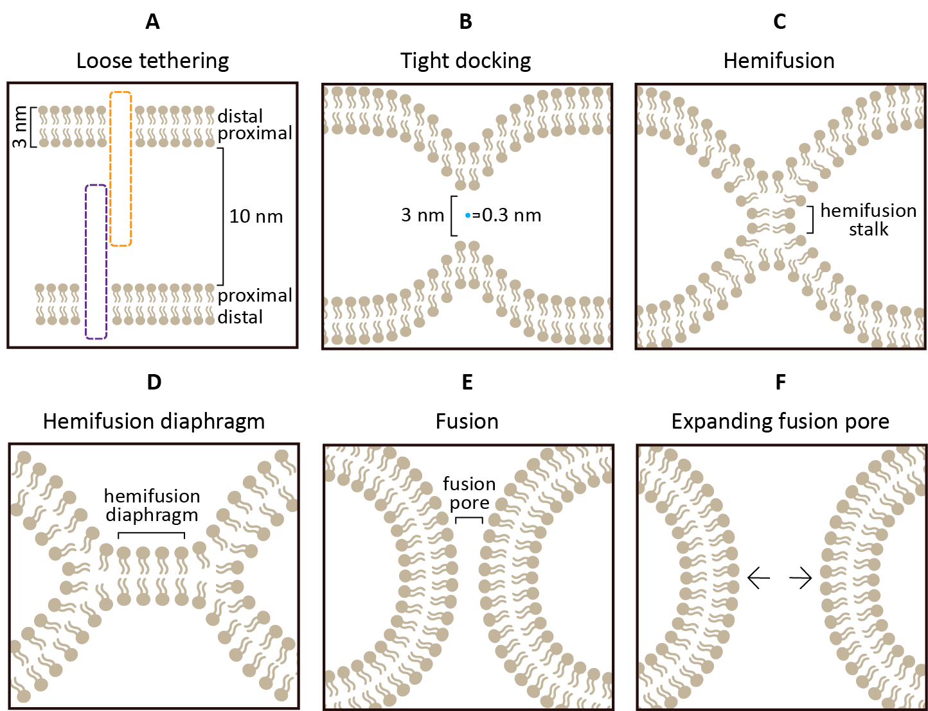

Figure 1. Steps of membrane fusion. All membrane fusion processes are thought proceed along the same basic sequence of lipid intermediates. (A) In loose adhesion, the two fusing bilayers are separated by a distance of approximately 10 to 20 nm. (B) In tight docking, small regions of each bilayer are brought to within ~3 nm of each other. For context, one molecule of water (blue dot) has a diameter of ~0.3 nm. (C) The proximal monolayers of each bilayer merge to form a hemifusion stalk. (D) The hemifusion stalk may widen into a hemifusion diaphragm, although this intermediate does not appear to be universal. (Akimov et al., 2014; H.-J. Liu et al., 2008) (E) The distal monolayers also fuse to form a fusion pore. (F) The fusion pore expands (Chernomordik et al., 2006). Figure after (Chernomordik & Kozlov, 2008).

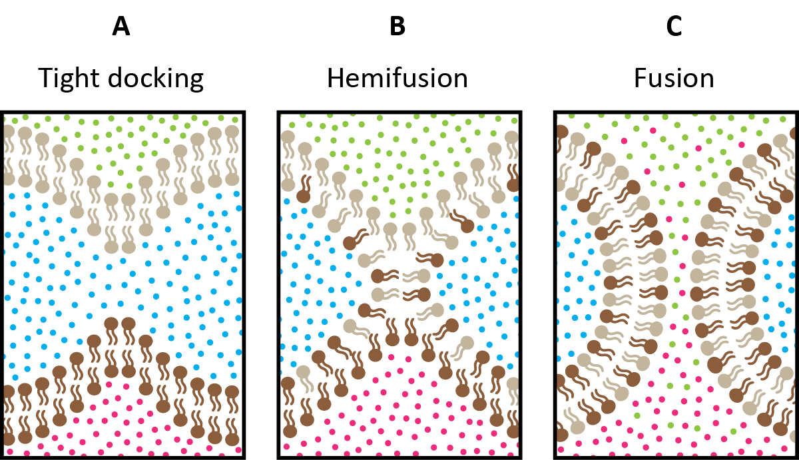

Figure 2. Lipid mixing and content mixing. (A) Here, two tightly adhered bilayers are color-coded tan and brown. Green and pink dots represent the contents of each fusing body. Blue dots represent the aqueous solution between the two membranes. (B) Hemifusion is characterized by the fusion of the proximal monolayers; lipid mixing is observable between the fused proximal monolayers but not between the distal monolayers. (C) Fusion is characterized by distal monolayer fusion and content mixing. Figure after _________.

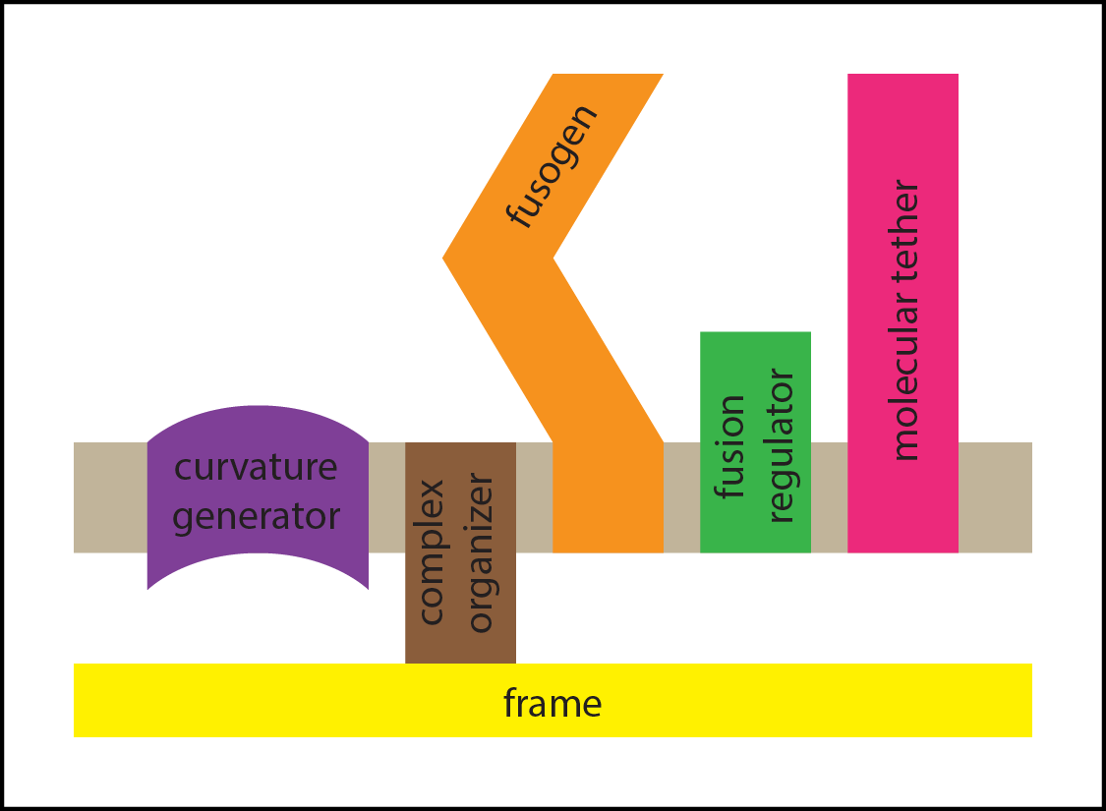

## Figure 3. Membrane fusion machine.

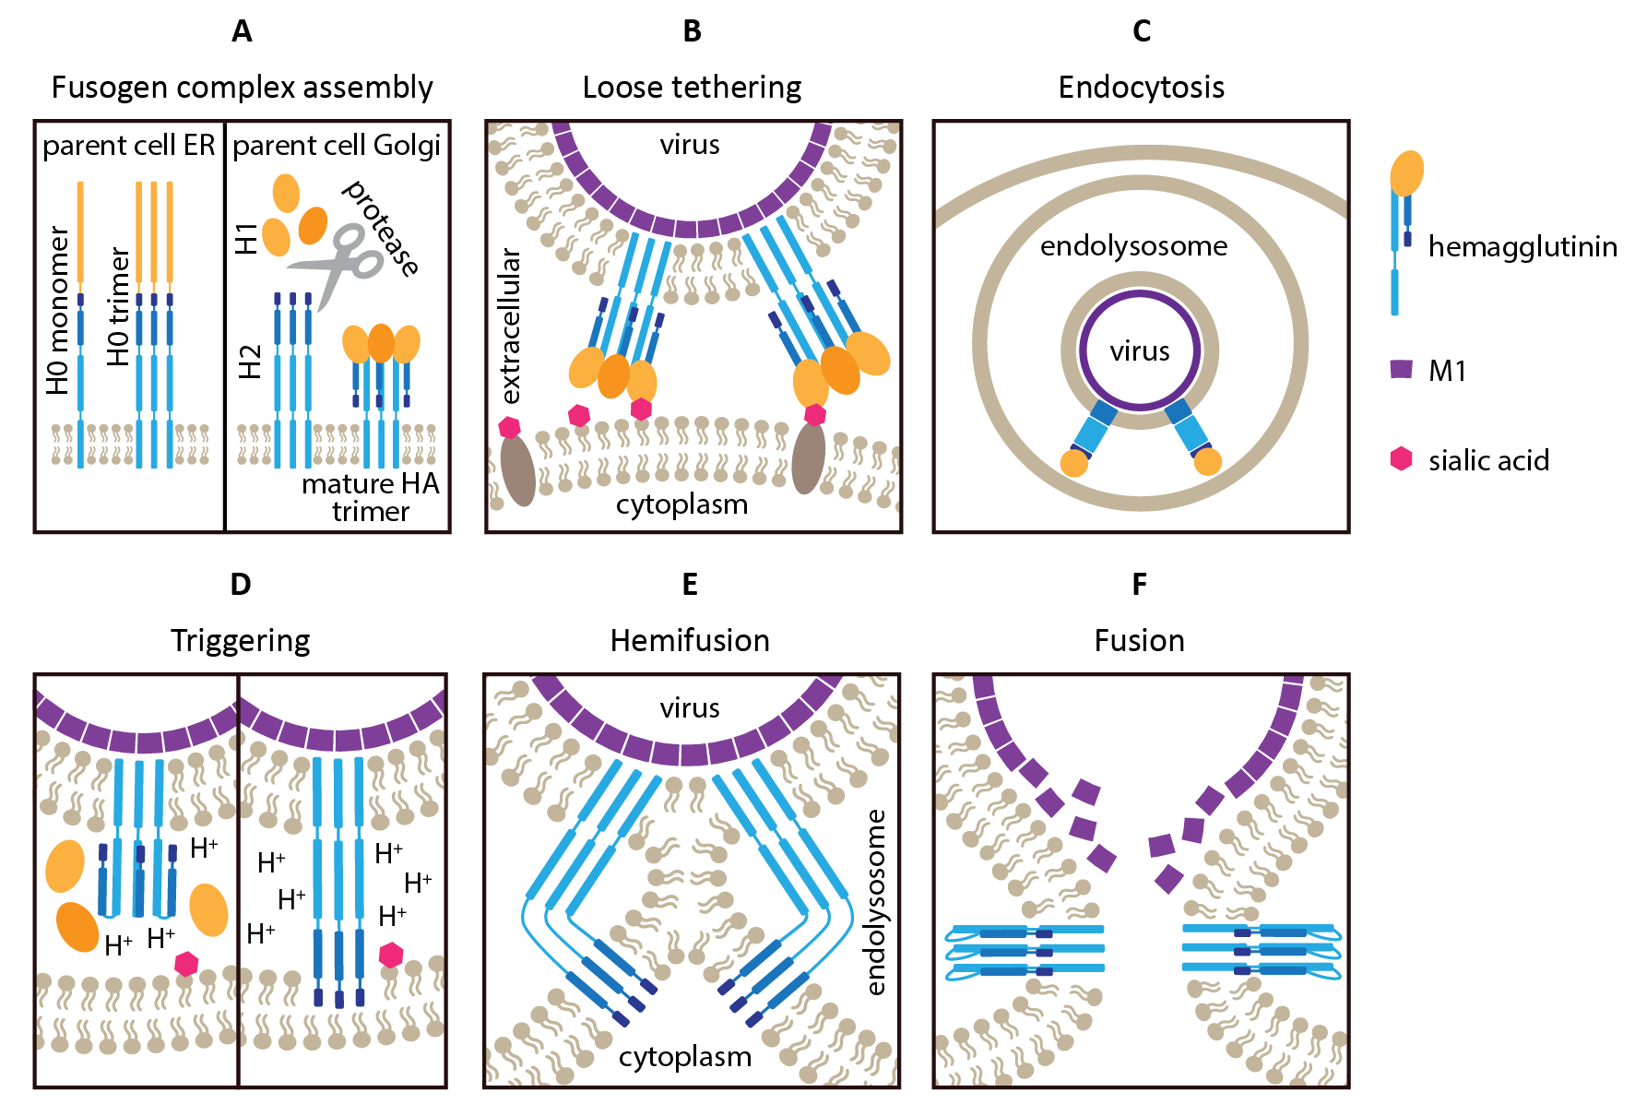

Figure 4. Influenza A and hemagglutinin. (A) HA is synthesized in the host cell as an inactive precursor protein (HA0), which is then cleaved into two disulfide-bonded subunits (HA1 and HA2) (Garcia, Guttman, Ebner, & Lee, 2015; Weis et al., 1988). The HA2 subunit contains a single transmembrane domain and a hydrophobic N-terminal “fusion peptide” capable of inserting into the target cell membrane. Prior to membrane fusion, HA2 is folded into a hairpin and held in place by the regulatory subunit HA1. These HA1/HA2 complexes form trimers in the mature viral envelope. (B) When a mature virus encounters a cell, the HA1 subunit serves as the hemagglutinin complex’s molecular tether. HA1 enables the virus to adhere to its target cell by recognizing sialic acid on proteins and lipids at the cell surface (Weis et al., 1988). (C) After the Influenza A virus binds to sialic acid, it is endocytosed by the target cell. The virus, which is now attached to the interior leaflet of the endosome membrane, must fuse with the endosome in order to access to the cytoplasm. (D) As the virus-containing endosome “matures,” its pH decreases, which in turn causes HA1 to disassociate from HA2. (E, F) Following the removal of HA1, HA2 extends and inserts its hydrophobic N-terminal fusion peptide into the host cell membrane (Garcia et al., 2015). The extended protein refolds into a hairpin, pulling the viral and endosomal membranes together (Blijleven et al., 2016). The mechanical force of this action overcomes the energetic barriers to tight adhesion, hemifusion, and fusion pore formation in quick succession. Multiple neighboring HA trimers are thought to work in concert, with each contributing a portion of the energy required for membrane fusion (Boonstra et al., 2018). Figure after ___________.

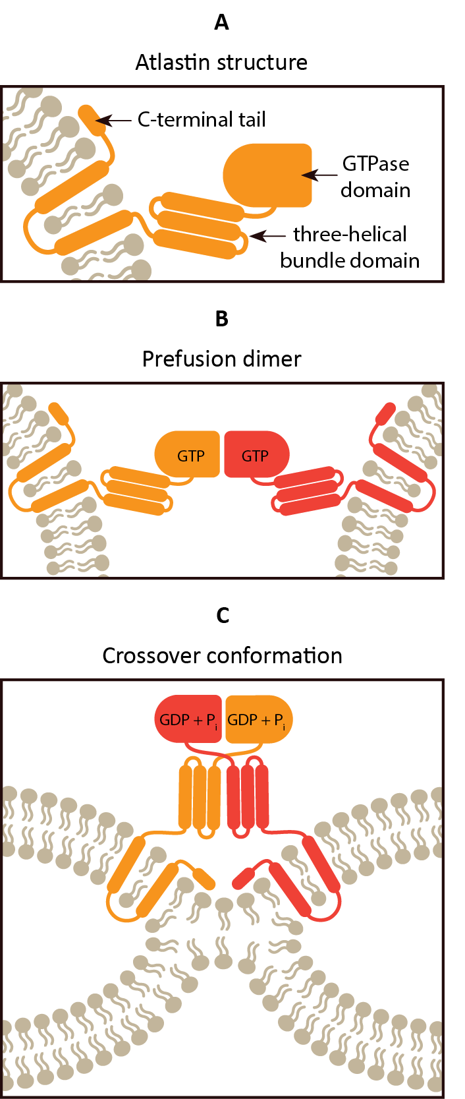

Figure 5: Atlastin and endoplasmic reticulum fusion. (A) From N-terminus to C-terminus, *D. melanogaster* atlastin consists of a GTPase domain, a stalk composed of a three-helical bundle domain, two closely-spaced transmembrane domains, and a C-terminal tail (see Figure 6A) (Bian et al., 2011). Both the N-terminal and C-terminal ends of the protein are on the cytoplasmic side of the endoplasmic reticulum membrane (Bian et al., 2011; T. Y. Liu et al., 2015; Zhu et al., 2003). The C-terminal tail of atlastin contains an amphipathic helix that contributes to membrane fusion by binding to and locally destabilizing the membrane (Bian et al., 2011; Faust et al., 2015; T. Y. Liu et al., 2012; Moss et al., 2011). (B) GTP-bound atlastin monomers on each fusing membrane first tether the membranes together, binding via their GTPase domains (Bian et al., 2011). (C) Each atlastin molecule then hydrolyzes GTP (T. Y. Liu et al., 2015). GTP hydrolysis triggers a conformational change, causing the two atlastin molecules to “cross over” and tightly associate along their helical bundle domains (Bian et al., 2011; T. Y. Liu et al., 2012; Moss, Andreazza, Verma, Daga, & McNew, 2011). The formation of this crossover conformation helps power the lipid rearrangements of fusion (Saini, Liu, Zhang, Lee, & Glick, 2014). The dimer eventually disassociates back into monomers. Membrane fusion requires the activity of multiple atlastin dimers in each membrane, and multiple dimerization and hydrolysis cycles may be required before membrane fusion occurs (T. Y. Liu et al., 2015). After (H.-J. Liu et al., 2008; O’Donnell et al., 2017; Winsor, Hackney, & Lee, 2017) Figure after _________.

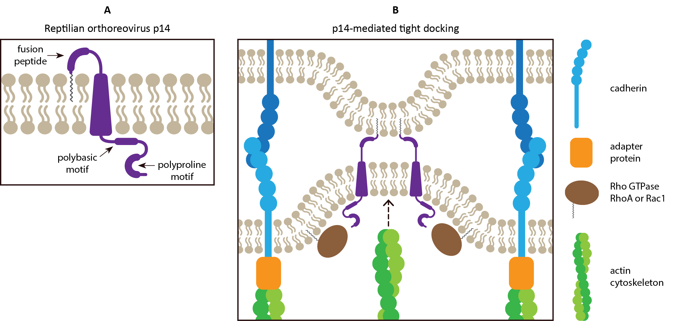

Figure 6: The FAST proteins: simple fusogens. (A) Six FAST proteins have been identified to date: p10, p13, p14, p15, p16, p22 (Ciechonska & Duncan, 2014b). They are small, ranging from 95–198 amino acids in length, and are named after their molecular masses (Boutilier & Duncan, 2011). The ectodomains of all six FAST proteins are acylated (Boutilier & Duncan, 2011) and some contain fusion peptides (Barry, Key, Haddad, & Duncan, 2010; Corcoran et al., 2004; Shmulevitz et al., 2004; Top, Read, Dawe, Syvitski, & Duncan, 2012). p14 is shown as an example. (B) FAST proteins in the plasma membrane of an infected cell self-associate into multimers and localize to lipid rafts (not shown) (Ciechonska & Duncan, 2014b). The ectodomains of FAST proteins are too small to mediate adhesion between adjacent cells; the ectodomain of p14, for instance, extends less than 1.5 nm from the membrane (Corcoran et al., 2006). As a result, FAST proteins rely on cellular cadherins and other adhesins, cellular signaling by the Rho GTPases RhoA and Rac1, and actin remodeling to promote fusion (Salsman, Top, Barry, & Duncan, 2008). Insertion of the fusion peptide and/or lipid chain into the plasma membrane of the target cell is thought to mediate dimple formation and tight docking; it may also induce membrane curvature (Boutilier & Duncan, 2011; Ciechonska & Duncan, 2014b).

Figure after __________

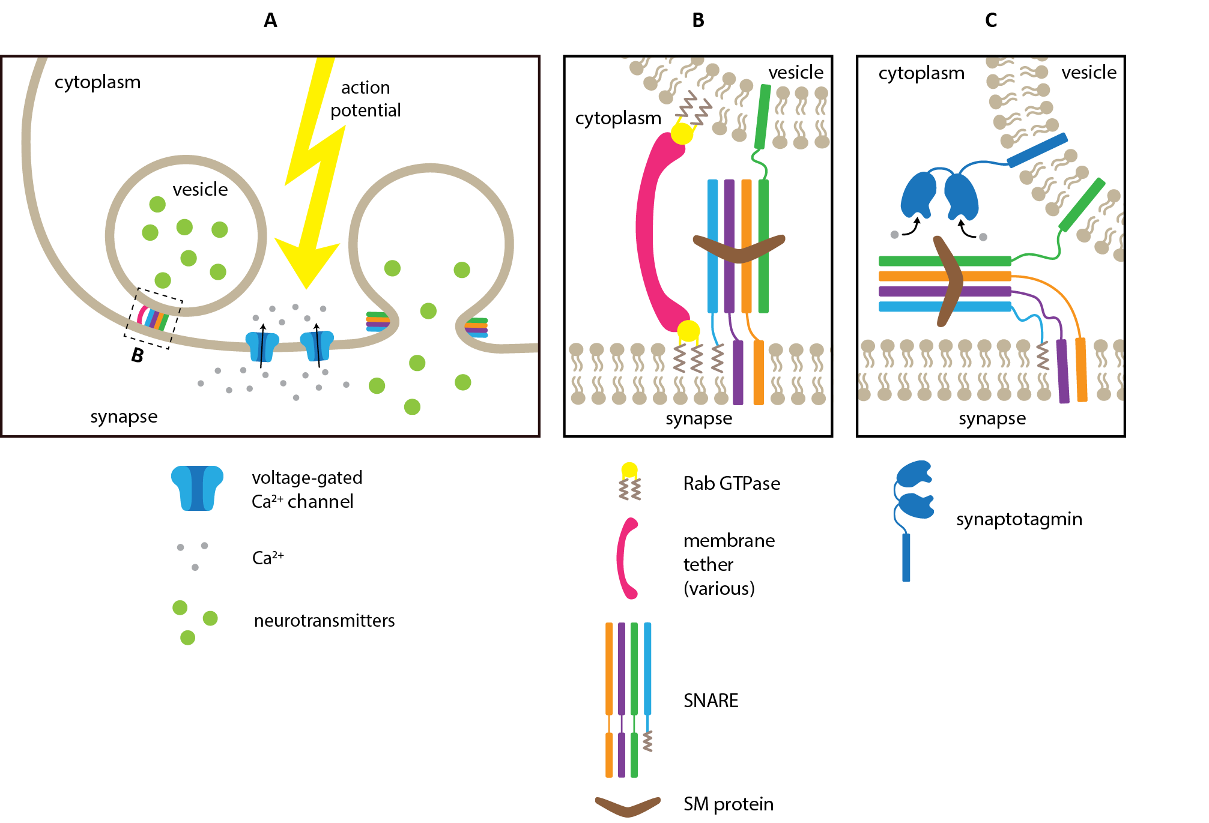

## Figure 7. Synaptic vesicle fusion.

Figure after ___________.

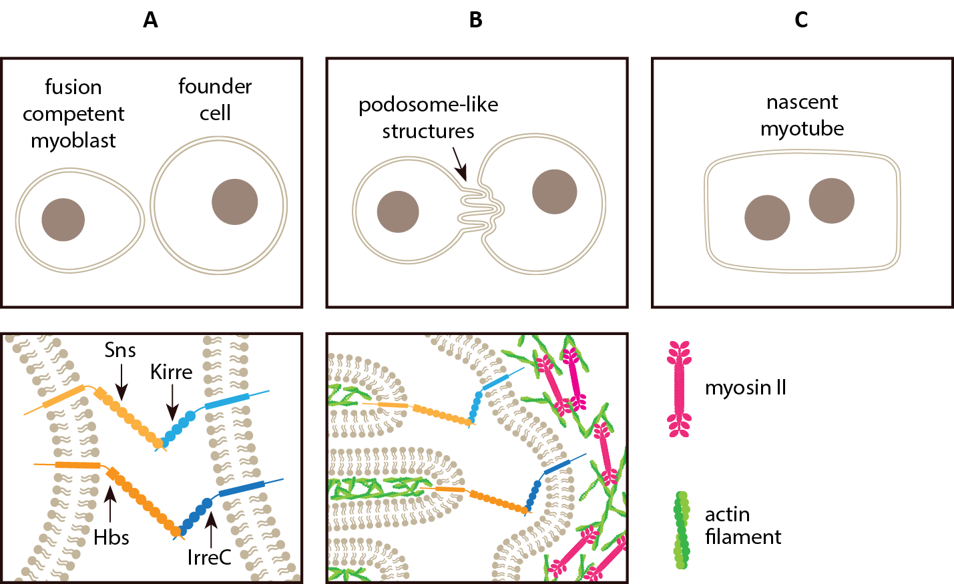

## Figure 8. Myoblast fusion.

Figure after ____________.

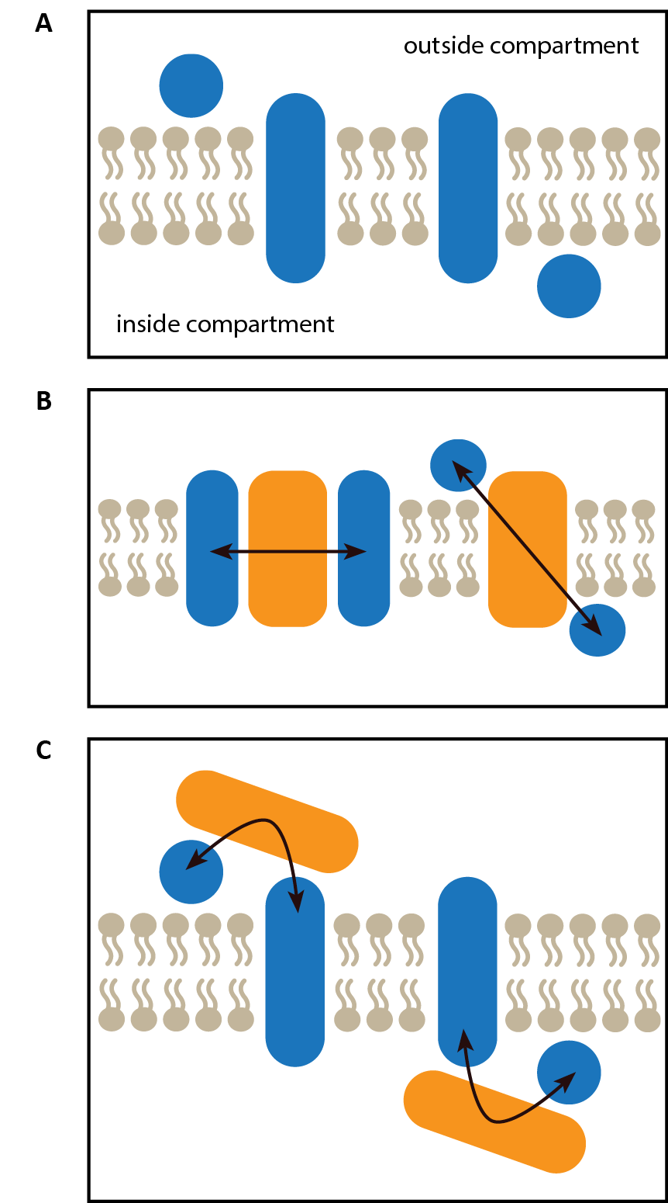

## Figure 9. Complex organizer schematic.

## Figure 10. Membrane curvature generators.

# SUPPLEMENTAL FIGURES

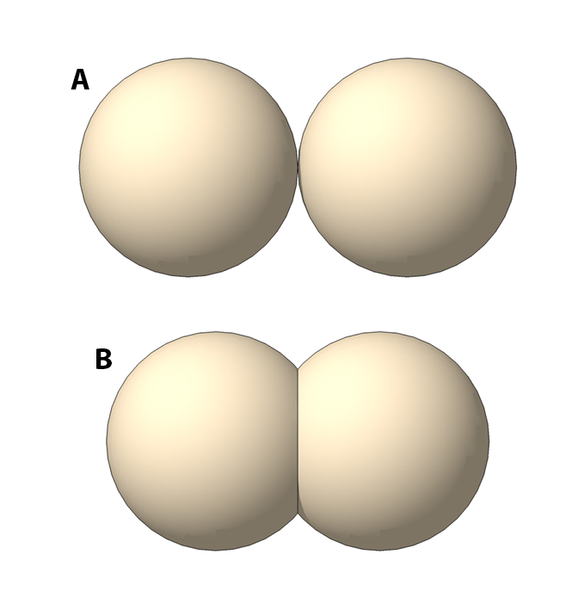

Supplemental Figure 1. Membrane deformation. (A) Two spherical membrane-enclosed compartments would make contact at a single point. (B) Adhesion over a larger surface area would require deformation of one or both membranes.

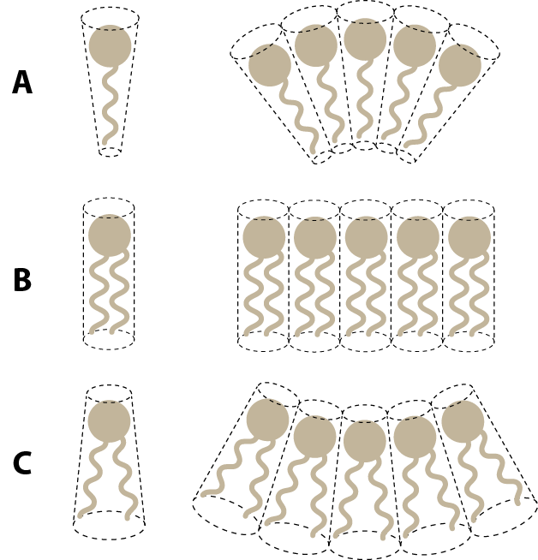

## Supplemental Figure 2. Spontaneous curvature.

The spontaneous curvature of a membrane depends in part on the shapes of the lipids that compose it. Lipids with positive spontaneous positive curvature produce monolayers that bulge outward (A). Lipids with zero spontaneous curvature produce flat monolayers (B). Lipids with negative spontaneous curvature produce monolayers that bulge inward (C). The spontaneous curvature of a given lipid may depend on environmental conditions. The energy required to bend a phospholipid bilayer depends in part on the spontaneous curvature of its constituent lipids.

Figure after (Cohen & Melikyan, 2004).

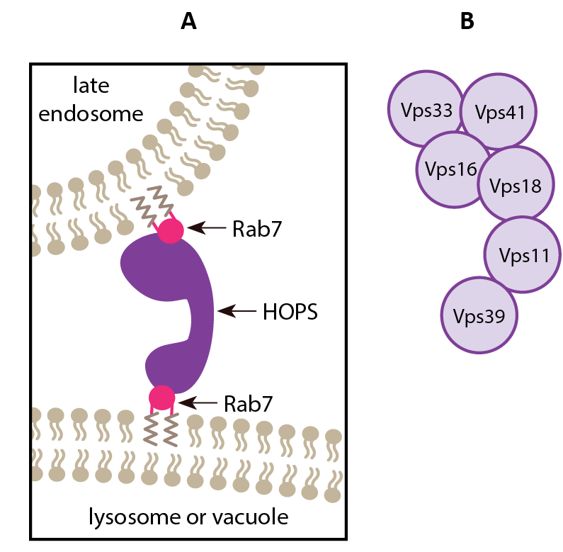

Supplemental Figure 3. HOPS complex. (A) The “homotypic fusion and protein sorting” (HOPS) complex is a multisubunit tethering complex that mediates fusion between late endosomes and lysosomes or vacuoles in yeast (see Supplemental Figure 3) (Balderhaar & Ungermann, 2013). ** TALK ABOUT Rab7 ** (B) The HOPS complex is composed of six different subunits.

Figure after (Balderhaar & Ungermann, 2013)

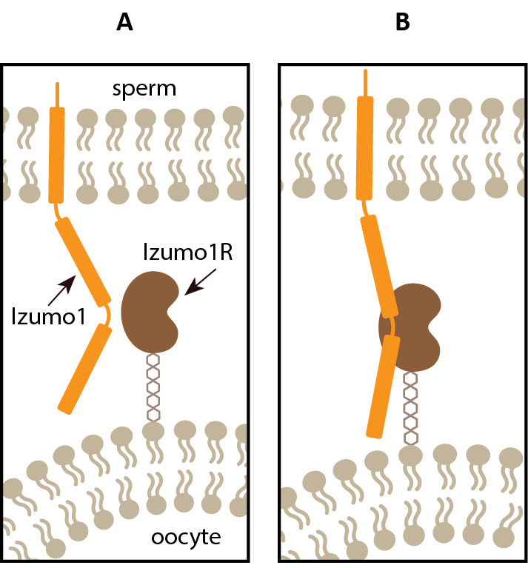

Supplemental Figure 4. Mammalian fertilization. (A) Izumo1 is a single-pass transmembrane protein expressed on mammalian sperm that possesses a four-alpha helix “Izumo” domain and an immunoglobulin-like domain (Ellerman et al., 2009). The Izumo and immunogloblin-like domains are connected by a flexible “hinge,” giving the Izumo1 ectodomain a boomerang-like shape (Aydin, Sultana, Li, Thavalingam, & Lee, 2016).Izumo1 receptor (Izumo1R) is a globular protein anchored to the oocyte membrane by ___________.Studies on the extracellular domains of Izumo1 and Juno suggest that the proteins are monomeric and interact in a 1:1 ratio (Aydin et al., 2016; Ohto et al., 2016). However, some evidence suggests that Izumo1 may function as a higher-order multimer. (Inoue, Hagihara, Wright, Suzuki, & Wada, 2015; Inoue & Wada, 2018) (B) Upon binding to Juno, the ectodomain of Izumo straightens from its boomerang shape to adopt a more “upright” position (Aydin et al., 2016).

Figure after ______.

Supplemental Figure 5. Tetraspanins. __________. Figure after _______.

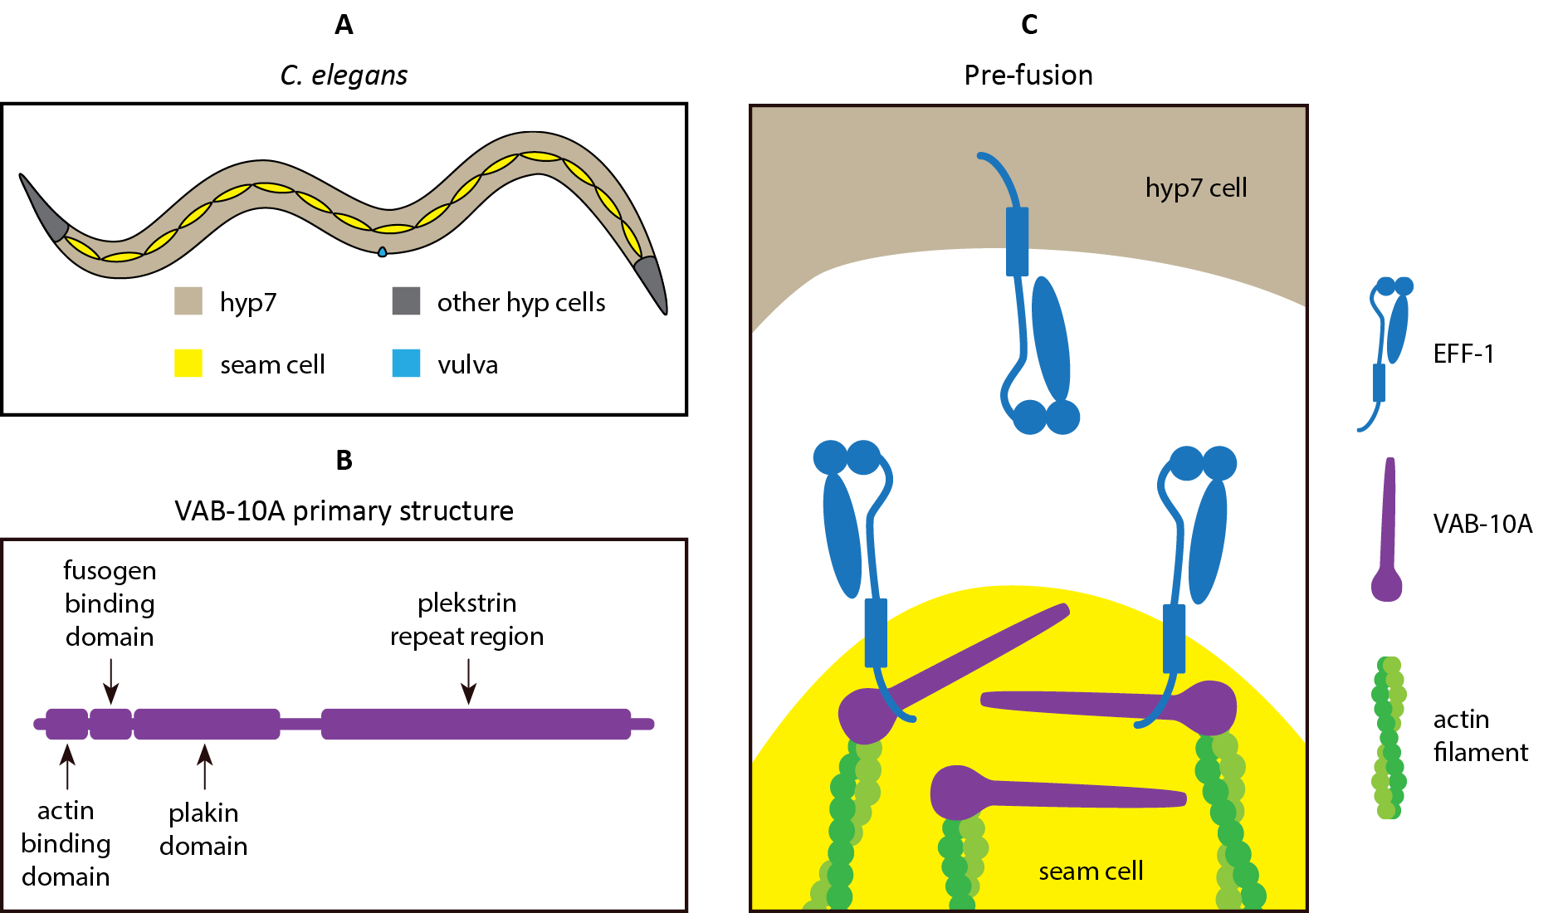

Supplemental Figure 6: VAB-10A as a complex organizer in C. elegans. VAB-10A consists of an actin-binding domain, a fusogen-binding domain, a plakin domain consisting of an SH3 domain flanked on each side by three spectrin repeat domains, and a region containing multiple plectrin repeats. Spectrin repeat domains act as flexible linker between actin and other elements, and can mediate parallel or anti-parallel dimerization between two molecules (Gally et al., 2016; Liem, 2016; Suozzi et al., 2012). The intracellular domain of EFF-1 binds to a “fusogen binding domain” located between the actin binding and plakin domains. Figure after _______.

# WORKS CITED

Akimov, S. A., Molotkovsky, R. J., Galimzyanov, T. R., Radaev, A. V, Shilova, L. A., Kuzmin, P. I., … Chizmadzhev, Y. A. (2014). Model of membrane fusion: Continuous transition to fusion pore with regard of hydrophobic and hydration interactions. *Biochemistry (Moscow) Supplement Series A: Membrane and Cell Biology*, *8*(2), 153–161.

Alper, S., & Podbilewicz, B. (2008). Cell Fusion in Caenorhabditis elegans. In E. H. Chen (Ed.), *Cell Fusion: Overviews and Methods* (pp. 53–74). Totowa, NJ: Humana Press. https://doi.org/10.1007/978-1-59745-250-2_4

Anantharam, A., Bittner, M. A., Aikman, R. L., Stuenkel, E. L., Schmid, S. L., Axelrod, D., … Martin, T. F. J. (2011). A new role for the dynamin GTPase in the regulation of fusion pore expansion. *Molecular Biology of the Cell*, *22*(11), 1907–1918. https://doi.org/10.1091/mbc.e11-02-0101

Aydin, H., Sultana, A., Li, S., Thavalingam, A., & Lee, J. E. (2016). Molecular architecture of the human sperm IZUMO1 and egg JUNO fertilization complex. *Nature*, *534*(7608), 562.

Baker, R. W., & Hughson, F. M. (2016). Chaperoning SNARE assembly and disassembly. *Nat Rev Mol Cell Biol*, *advance on*. https://doi.org/10.1038/nrm.2016.65

Balderhaar, H. J. kleine, & Ungermann, C. (2013). CORVET and HOPS tethering complexes &lt;strong&gt;–&lt;/strong&gt; coordinators of endosome and lysosome fusion. *Journal of Cell Science*, *126*(6), 1307 LP – 1316. https://doi.org/10.1242/jcs.107805

Barry, C., Key, T., Haddad, R., & Duncan, R. (2010). Features of a spatially constrained cystine loop in the p10 FAST protein ectodomain define a new class of viral fusion peptides. *Journal of Biological Chemistry*. https://doi.org/10.1074/jbc.M110.118232

Batishchev, O. V, Shilova, L. A., Kachala, M. V, Tashkin, V. Y., Sokolov, V. S., Fedorova, N. V, … Chizmadzhev, Y. A. (2016). pH-dependent formation and disintegration of the influenza A virus protein scaffold to provide tension for membrane fusion. *Journal of Virology*, *90*(1), 575–585.

Bello, O. D., Jouannot, O., Chaudhuri, A., Stroeva, E., Coleman, J., Volynski, K. E., … Krishnakumar, S. S. (2018). Synaptotagmin oligomerization is essential for calcium control of regulated exocytosis. *Proceedings of the National Academy of Sciences*, *115*(32), E7624 LP-E7631. https://doi.org/10.1073/pnas.1808792115

Bi, P., McAnally, J. R., Shelton, J. M., Sánchez-Ortiz, E., Bassel-Duby, R., & Olson, E. N. (2018). Fusogenic micropeptide Myomixer is essential for satellite cell fusion and muscle regeneration. *Proceedings of the National Academy of Sciences*, 201800052.

Bian, X., Klemm, R. W., Liu, T. Y., Zhang, M., Sun, S., Sui, X., … Hu, J. (2011). Structures of the atlastin GTPase provide insight into homotypic fusion of endoplasmic reticulum membranes. *Proceedings of the National Academy of Sciences*, 201101643.

Bianchi, E., Doe, B., Goulding, D., & Wright, G. J. (2014). Juno is the egg Izumo receptor and is essential for mammalian fertilization. *Nature*, *508*, 483. Retrieved from https://doi.org/10.1038/nature13203

Blijleven, J. S., Boonstra, S., Onck, P. R., van der Giessen, E., & van Oijen, A. M. (2016). Mechanisms of influenza viral membrane fusion. In *Seminars in Cell & Developmental Biology*. Elsevier.

Boavida, L. C., Qin, P., Broz, M., Becker, J. D., & McCormick, S. (2013). Arabidopsis Tetraspanins Are Confined to Discrete Expression Domains and Cell Types in Reproductive Tissues and Form Homo- and Heterodimers When Expressed in Yeast. *Plant Physiology*, *163*(2), 696–712. https://doi.org/10.1104/pp.113.216598

Boonstra, S., Blijleven, J. S., Roos, W. H., Onck, P. R., van der Giessen, E., & van Oijen, A. M. (2018). Hemagglutinin-Mediated Membrane Fusion: A Biophysical Perspective. *Annual Review of Biophysics*, *47*(1), 153–173. https://doi.org/10.1146/annurev-biophys-070317-033018

Boutilier, J., & Duncan, R. (2011). The reovirus fusion-associated small transmembrane (FAST) proteins: virus-encoded cellular fusogens. In *Current topics in membranes* (Vol. 68, pp. 107–140). Elsevier.

Brunger, A. T., Leitz, J., Zhou, Q., Choi, U. B., & Lai, Y. (2018). Ca2+-Triggered Synaptic Vesicle Fusion Initiated by Release of Inhibition. *Trends in Cell Biology*, *28*(8), 631–645. https://doi.org/https://doi.org/10.1016/j.tcb.2018.03.004

Bürmann, F., Ebert, N., van Baarle, S., & Bramkamp, M. (2011). A bacterial dynamin‐like protein mediating nucleotide‐independent membrane fusion. *Molecular Microbiology*, *79*(5), 1294–1304.

Cécile, V., & Hans-Peter, H. (2006). Morphogenesis of the Endoplasmic Reticulum: Beyond Active Membrane Expansion. *Traffic*, *7*(6), 639–646. https://doi.org/doi:10.1111/j.1600-0854.2006.00419.x

Charrin, S., Jouannet, S., Boucheix, C., & Rubinstein, E. (2014). Tetraspanins at a glance. *Journal of Cell Science*, *127*(17), 3641 LP – 3648. https://doi.org/10.1242/jcs.154906

Chernomordik, L. V, & Kozlov, M. M. (2003). Protein-lipid interplay in fusion and fission of biological membranes. *Annual Review of Biochemistry*, *72*(1), 175–207.

Chernomordik, L. V, & Kozlov, M. M. (2005). Membrane hemifusion: crossing a chasm in two leaps. *Cell*, *123*(3), 375–382.

Chernomordik, L. V, & Kozlov, M. M. (2008). Mechanics of membrane fusion. *Nature Structural & Molecular Biology*, *15*(7), 675–683.

Chernomordik, L. V, Zimmerberg, J., & Kozlov, M. M. (2006). Membranes of the world unite! *The Journal of Cell Biology*, *175*(2), 201–207.

Chua, K. B., Crameri, G., Hyatt, A., Yu, M., Tompang, M. R., Rosli, J., … Wang, L.-F. (2007). A previously unknown reovirus of bat origin is associated with an acute respiratory disease in humans. *Proceedings of the National Academy of Sciences*, *104*(27), 11424–11429. https://doi.org/10.1073/pnas.0701372104

Chua, K. B., Voon, K., Crameri, G., Tan, H. S., Rosli, J., McEachern, J. A., … Wang, L.-F. (2008). Identification and characterization of a new orthoreovirus from patients with acute respiratory infections. *PloS One*, *3*(11), e3803.

Ciechonska, M., & Duncan, R. (2014a). Lysophosphatidylcholine Reversibly Arrests Pore Expansion during Syncytium Formation Mediated by Diverse Viral Fusogens. *Journal of Virology*, *88*(11), 6528–6531. https://doi.org/10.1128/jvi.00314-14

Ciechonska, M., & Duncan, R. (2014b). Reovirus FAST proteins: virus-encoded cellular fusogens. *Trends in Microbiology*, *22*(12), 715–724. https://doi.org/https://doi.org/10.1016/j.tim.2014.08.005

Codding, S. J., Marty, N., Abdullah, N., & Johnson, C. P. (2016). Dysferlin Binds SNAREs (Soluble N-Ethylmaleimide-sensitive Factor (NSF) Attachment Protein Receptors) and Stimulates Membrane Fusion in a Calcium-sensitive Manner. *Journal of Biological Chemistry* , *291*(28), 14575–14584. https://doi.org/10.1074/jbc.M116.727016

Cohen, F. S., & Melikyan, G. B. (2004). The Energetics of Membrane Fusion from Binding, through Hemifusion, Pore Formation, and Pore Enlargement. *The Journal of Membrane Biology*, *199*(1), 1–14. https://doi.org/10.1007/s00232-004-0669-8

Corcoran, J. A., Salsman, J., de Antueno, R., Touhami, A., Jericho, M. H., Clancy, E. K., & Duncan, R. (2006). The p14 Fusion-associated Small Transmembrane (FAST) Protein Effects Membrane Fusion from a Subset of Membrane Microdomains. *Journal of Biological Chemistry*, *281*(42), 31778–31789. https://doi.org/10.1074/jbc.M602566200

Corcoran, J. A., Syvitski, R., Top, D., Epand, R. M., Epand, R. F., Jakeman, D., & Duncan, R. (2004). Myristoylation, a Protruding Loop, and Structural Plasticity Are Essential Features of a Nonenveloped Virus Fusion Peptide Motif. *Journal of Biological Chemistry*, *279*(49), 51386–51394. https://doi.org/10.1074/jbc.M406990200

D., C. A., & I., H. T. (2012). The Caenorhabditis elegans epidermis as a model skin. I: development, patterning, and growth. *Wiley Interdisciplinary Reviews: Developmental Biology*, *1*(6), 861–878. https://doi.org/doi:10.1002/wdev.79

del Campo, J. J., Opoku-Serebuoh, E., Isaacson, A. B., Scranton, V. L., Tucker, M., Han, M., & Mohler, W. A. (2005). Fusogenic activity of EFF-1 is regulated via dynamic localization in fusing somatic cells of C. elegans. *Current Biology*, *15*(5), 413–423.

Dmitrieff, S., & Nédélec, F. (2016). Amplification of actin polymerization forces. *The Journal of Cell Biology*, *212*(7), 763 LP – 766. https://doi.org/10.1083/jcb.201512019

Doherty, J. T., Lenhart, K. C., Cameron, M. V, Mack, C. P., Conlon, F. L., & Taylor, J. M. (2011). Skeletal muscle differentiation and fusion is regulated by the BAR-containing Rho GAP, GRAF1. *Journal of Biological Chemistry*, jbc. M111. 243030.

Doherty, K. R., Cave, A., Davis, D. B., Delmonte, A. J., Posey, A., Earley, J. U., … McNally, E. M. (2005). Normal myoblast fusion requires myoferlin. *Development*, *132*(24), 5565 LP – 5575. https://doi.org/10.1242/dev.02155

Doms, R. W. (2017). What Came First—the Virus or the Egg? *Cell*, *168*(5), 755–757. https://doi.org/https://doi.org/10.1016/j.cell.2017.02.012

Dreier, L., & Rapoport, T. A. (2000). In vitro formation of the endoplasmic reticulum occurs independently of microtubules by a controlled fusion reaction. *The Journal of Cell Biology*, *148*(5), 883–898.

Dubuke, M. L., & Munson, M. (2016). The Secret Life of Tethers: The Role of Tethering Factors in SNARE Complex Regulation. *Frontiers in Cell and Developmental Biology*, *4*(42). https://doi.org/10.3389/fcell.2016.00042

Ellerman, D. A., Pei, J., Gupta, S., Snell, W. J., Myles, D., & Primakoff, P. (2009). Izumo is part of a multiprotein family whose members form large complexes on mammalian sperm. *Molecular Reproduction and Development*, *76*(12), 1188–1199. https://doi.org/10.1002/mrd.21092

Evans, E. A., & Parsegian, V. A. (1983). Energetics of membrane deformation and adhesion in cell and vesicle aggregation. *Annals of the New York Academy of Sciences*, *416*(1), 13–33.

Fanaei, M., Monk, P. N., & Partridge, L. J. (2011). The role of tetraspanins in fusion. *Biochemical Society Transactions*, *39*(2), 524 LP – 528. https://doi.org/10.1042/BST0390524

Fanning, A. S., & Anderson, J. M. (1999). Protein modules as organizers of membrane structure. *Current Opinion in Cell Biology*, *11*(4), 432–439.

Faust, J. E., Desai, T., Verma, A., Ulengin, I., Sun, T.-L., Moss, T. J., … McNew, J. A. (2015). The Atlastin C-terminal Tail is an Amphipathic Helix that Perturbs Bilayer Structure during Endoplasmic Reticulum Homotypic Fusion. *Journal of Biological Chemistry*. https://doi.org/10.1074/jbc.M114.601823

Freund, L. B. (2013). Entropic pressure between biomembranes in a periodic stack due to thermal fluctuations. *Proceedings of the National Academy of Sciences*, *110*(6), 2047–2051. https://doi.org/10.1073/pnas.1220968110

Gally, C., Zhang, H., & Labouesse, M. (2016). Functional and Genetic Analysis of VAB-10 Spectraplakin in Caenorhabditis elegans. In *Methods in enzymology* (Vol. 569, pp. 407–430). Elsevier.

Garcia, N. K., Guttman, M., Ebner, J. L., & Lee, K. K. (2015). Dynamic Changes during Acid-Induced Activation of Influenza Hemagglutinin. *Structure*, *23*(4), 665–676. https://doi.org/http://dx.doi.org/10.1016/j.str.2015.02.006

Gould, S. B. (2018). Membranes and evolution. *Current Biology*, *28*(8), R381–R385. https://doi.org/https://doi.org/10.1016/j.cub.2018.01.086

Graham, T. R., & Kozlov, M. M. (2010). Interplay of proteins and lipids in generating membrane curvature. *Current Opinion in Cell Biology*, *22*(4), 430–436. https://doi.org/https://doi.org/10.1016/j.ceb.2010.05.002

Han, L., Nishimura, K., Sadat Al Hosseini, H., Bianchi, E., Wright, G. J., & Jovine, L. (2016). Divergent evolution of vitamin B9 binding underlies Juno-mediated adhesion of mammalian gametes. *Current Biology*, *26*(3), R100–R101. https://doi.org/https://doi.org/10.1016/j.cub.2015.12.034

Hanna, S. T., Pigeau, G. M., Galvanovskis, J., Clark, A., Rorsman, P., & MacDonald, P. E. (2009). Kiss-and-run exocytosis and fusion pores of secretory vesicles in human β-cells. *Pflügers Archiv-European Journal of Physiology*, *457*(6), 1343.

Hennig, R., Heidrich, J., Saur, M., Schmüser, L., Roeters, S. J., Hellmann, N., … Markl, J. (2015). IM30 triggers membrane fusion in cyanobacteria and chloroplasts. *Nature Communications*, *6*, 7018.

Hu, J., Shibata, Y., Zhu, P.-P., Voss, C., Rismanchi, N., Prinz, W. A., … Blackstone, C. (2009). A Class of Dynamin-like GTPases Involved in the Generation of the Tubular ER Network. *Cell*, *138*(3), 549–561. https://doi.org/10.1016/J.CELL.2009.05.025

Huang, S., Yuan, S., Dong, M., Su, J., Yu, C., Shen, Y., … Xu, A. (2005). The phylogenetic analysis of tetraspanins projects the evolution of cell–cell interactions from unicellular to multicellular organisms. *Genomics*, *86*(6), 674–684. https://doi.org/https://doi.org/10.1016/j.ygeno.2005.08.004

Inoue, N., Hagihara, Y., Wright, D., Suzuki, T., & Wada, I. (2015). Oocyte-triggered dimerization of sperm IZUMO1 promotes sperm–egg fusion in mice. *Nature Communications*, *6*, 8858.

Inoue, N., Ikawa, M., Isotani, A., & Okabe, M. (2005). The immunoglobulin superfamily protein Izumo is required for sperm to fuse with eggs. *Nature*, *434*, 234. Retrieved from https://doi.org/10.1038/nature03362

Inoue, N., & Wada, I. (2018). Monitoring dimeric status of IZUMO1 during the acrosome reaction in living spermatozoon. *Cell Cycle*, *17*(11), 1279–1285. https://doi.org/10.1080/15384101.2018.1489181

Israelachvili, J N. (1994). Strength of van der Waals Attraction between Lipid Bilayers. *Langmuir*, *10*(9), 3369–3370. https://doi.org/10.1021/la00021a077

Israelachvili, Jacob N, & Wennerstroem, H. (1992). Entropic forces between amphiphilic surfaces in liquids. *The Journal of Physical Chemistry*, *96*(2), 520–531.

Iwai, K., Ishii, M., Ohshima, S., Miyatake, K., & Saeki, Y. (2007). Expression and Function of Transmembrane-4 Superfamily (Tetraspanin) Proteins in Osteoclasts: Reciprocal Roles of Tspan-5 and NET-6 during Osteoclastogenesis. *Allergology International*, *56*(4), 457–463. https://doi.org/10.2332/allergolint.O-07-488

Johnson, C. P., & Chapman, E. R. (2010). Otoferlin is a calcium sensor that directly regulates SNARE-mediated membrane fusion. *The Journal of Cell Biology*, *191*(1), 187 LP – 197. https://doi.org/10.1083/jcb.201002089

Kaji, K., Oda, S., Shikano, T., Ohnuki, T., Uematsu, Y., Sakagami, J., … Kudo, A. (2000). The gamete fusion process is defective in eggs of Cd9-deficient mice. *Nature Genetics*, *24*(3), 279–282.

Kanduč, M., Schlaich, A., de Vries, A. H., Jouhet, J., Maréchal, E., Demé, B., … Schneck, E. (2017). Tight cohesion between glycolipid membranes results from balanced water–headgroup interactions. *Nature Communications*, *8*, 14899. https://doi.org/10.1038/ncomms14899

Kato, K., Satouh, Y., Nishimasu, H., Kurabayashi, A., Morita, J., Fujihara, Y., … Nureki, O. (2016). Structural and functional insights into IZUMO1 recognition by JUNO in mammalian fertilization. *Nature Communications*, *7*, 12198. https://doi.org/10.1038/ncomms12198https://www.nature.com/articles/ncomms12198#supplementary-information

Kehr, A. D., & Hinshaw, J. E. (2018). Cool views of membrane remodeling. *Current Opinion in Colloid & Interface Science*, *34*, 17–31. https://doi.org/https://doi.org/10.1016/j.cocis.2018.02.004

Kim, J. H., Ren, Y., Ng, W. P., Li, S., Son, S., Kee, Y.-S., … Robinson, D. N. (2015). Mechanical tension drives cell membrane fusion. *Developmental Cell*, *32*(5), 561–573.

Kozlov, M. M., & Chernomordik, L. V. (2015). Membrane tension and membrane fusion. *Current Opinion in Structural Biology*, *33*, 61–67.

Kozlov, M. M., McMahon, H. T., & Chernomordik, L. V. (2010). Protein-driven membrane stresses in fusion and fission. *Trends in Biochemical Sciences*, *35*(12), 699–706.

Kozlovsky, Y., & Kozlov, M. M. (2002). Stalk model of membrane fusion: solution of energy crisis. *Biophysical Journal*, *82*(2), 882–895.

Le Naour, F., Rubinstein, E., Jasmin, C., Prenant, M., & Boucheix, C. (2000). Severely reduced female fertility in CD9-deficient mice. *Science*, *287*(5451), 319–321.

Lee, K. K. (2010). Architecture of a nascent viral fusion pore. *The EMBO Journal*, *29*(7), 1299–1311.

Leikina, E., Melikov, K., Sanyal, S., Verma, S. K., Eun, B., Gebert, C., … Chernomordik, L. V. (2013). Extracellular annexins and dynamin are important for sequential steps in myoblast fusion. *The Journal of Cell Biology*, *200*(1), 109–123. https://doi.org/10.1083/jcb.201207012

Lek, A., Lek, M., North, K. N., & Cooper, S. T. (2010). Phylogenetic analysis of ferlin genes reveals ancient eukaryotic origins. *BMC Evolutionary Biology*, *10*, 231. https://doi.org/10.1186/1471-2148-10-231

Lenhart, K. C., Becherer, A. L., Li, J., Xiao, X., McNally, E. M., Mack, C. P., & Taylor, J. M. (2014). GRAF1 promotes ferlin-dependent myoblast fusion. *Developmental Biology*, *393*(2), 298–311. https://doi.org/https://doi.org/10.1016/j.ydbio.2014.06.025

Liem, R. K. H. (2016). Cytoskeletal integrators: the spectrin superfamily. *Cold Spring Harbor Perspectives in Biology*, *8*(10), a018259.

Lis, L. J., McAlister, M., Fuller, N., Rand, R. P., & Parsegian, V. A. (1982). Interactions between neutral phospholipid bilayer membranes. *Biophysical Journal*, *37*(3), 657–665. Retrieved from http://www.ncbi.nlm.nih.gov/pmc/articles/PMC1328851/

Liu, H.-J., Lin, P.-Y., Wang, L.-R., Hsu, H.-Y., Liao, M.-H., & Shih, W.-L. (2008). Activation of small GTPases RhoA and Rac1 is required for avian reovirus p10-induced syncytium formation. *Molecules & Cells (Springer Science & Business Media BV)*, *26*(4).

Liu, T. Y., Bian, X., Romano, F. B., Shemesh, T., Rapoport, T. A., & Hu, J. (2015). Cis and trans interactions between atlastin molecules during membrane fusion. *Proceedings of the National Academy of Sciences*, 201504368. Retrieved from http://www.pnas.org/content/early/2015/03/25/1504368112.short

Liu, T. Y., Bian, X., Sun, S., Hu, X., Klemm, R. W., Prinz, W. A., … Hu, J. (2012). Lipid interaction of the C terminus and association of the transmembrane segments facilitate atlastin-mediated homotypic endoplasmic reticulum fusion. *Proceedings of the National Academy of Sciences*, *109*(32), E2146–E2154.

Lohner, J., Rupprecht, J.-F., Hu, J., Mandriota, N., Saxena, M., Hone, J., … Sheetz, M. (2018). Myosin filaments reversibly generate large forces in cells. *BioRxiv*, 296400. https://doi.org/10.1101/296400

Marra, J. (1986). Direct measurements of attractive van der Waals and adhesion forces between uncharged lipid bilayers in aqueous solutions. *Journal of Colloid and Interface Science*, *109*(1), 11–20.

Martin, S. G. (2016). Role and organization of the actin cytoskeleton during cell-cell fusion. In *Seminars in Cell & Developmental Biology* (Vol. 60, pp. 121–126). Elsevier.

McBride, H. M. (2018). Mitochondria and endomembrane origins. *Current Biology*, *28*(8), R367–R372. https://doi.org/https://doi.org/10.1016/j.cub.2018.03.052

Miyado, K., Yamada, G., Yamada, S., Hasuwa, H., Nakamura, Y., Ryu, F., … Ogura, A. (2000). Requirement of CD9 on the egg plasma membrane for fertilization. *Science*, *287*(5451), 321–324.

Mohler, W. A., Shemer, G., del Campo, J. J., Valansi, C., Opoku-Serebuoh, E., Scranton, V., … Podbilewicz, B. (2002). The type I membrane protein EFF-1 is essential for developmental cell fusion. *Developmental Cell*, *2*(3), 355–362.

Molotkovsky, R. J., Kuzmin, P. I., & Akimov, S. A. (2015). Membrane fusion. Two possible mechanisms underlying a decrease in the fusion energy barrier in the presence of fusion proteins. *Biochemistry (Moscow) Supplement Series A: Membrane and Cell Biology*, *9*(2), 65–76. https://doi.org/10.1134/s1990747815020075

Moss, T. J., Andreazza, C., Verma, A., Daga, A., & McNew, J. A. (2011). Membrane fusion by the GTPase atlastin requires a conserved C-terminal cytoplasmic tail and dimerization through the middle domain. *Proceedings of the National Academy of Sciences*, *108*(27), 11133–11138. https://doi.org/10.1073/pnas.1105056108

Munro, S. (2011). The golgin coiled-coil proteins of the Golgi apparatus. *Cold Spring Harbor Perspectives in Biology*, *3*(6), a005256.

Muschalik, N., & Munro, S. (2018). Golgins. *Current Biology*, *28*(8), R374–R376. https://doi.org/https://doi.org/10.1016/j.cub.2018.01.006

Norton, R. L. (2000). *Machine Design — An Integrated Approach* (2nd ed.). Prentice Hall.

O’Donnell, J. P., Cooley, R. B., Kelly, C. M., Miller, K., Andersen, O. S., Rusinova, R., & Sondermann, H. (2017). Timing and reset mechanism of GTP hydrolysis-driven conformational changes of atlastin. *Structure*, *25*(7), 997-1010. e4.

Ohto, U., Ishida, H., Krayukhina, E., Uchiyama, S., Inoue, N., & Shimizu, T. (2016). Structure of IZUMO1–JUNO reveals sperm–oocyte recognition during mammalian fertilization. *Nature*, *534*, 566. https://doi.org/10.1038/nature18596https://www.nature.com/articles/nature18596#supplementary-information

Orso, G., Pendin, D., Liu, S., Tosetto, J., Moss, T. J., Faust, J. E., … Daga, A. (2009). Homotypic fusion of ER membranes requires the dynamin-like GTPase Atlastin. *Nature*, *460*, 978. Retrieved from https://doi.org/10.1038/nature08280

Papadopulos, A. (2017). Membrane shaping by actin and myosin during regulated exocytosis. *Molecular and Cellular Neuroscience*, *84*, 93–99. https://doi.org/https://doi.org/10.1016/j.mcn.2017.05.006

Park, S. H., Zhu, P.-P., Parker, R. L., & Blackstone, C. (2010). Hereditary spastic paraplegia proteins REEP1, spastin, and atlastin-1 coordinate microtubule interactions with the tubular ER network. *The Journal of Clinical Investigation*, *120*(4), 1097–1110. https://doi.org/10.1172/JCI40979

Park, Y., & Ryu, J.-K. (2018). Models of synaptotagmin-1 to trigger Ca2+-dependent vesicle fusion. *FEBS Letters*, *592*(21), 3480–3492. https://doi.org/10.1002/1873-3468.13193

Parsegian, V. A., & Zemb, T. (2011). Hydration forces: Observations, explanations, expectations, questions. *Current Opinion in Colloid & Interface Science*, *16*(6), 618–624.

Pérez-Vargas, J., Krey, T., Valansi, C., Avinoam, O., Haouz, A., Jamin, M., … Rey, F. A. (2014). Structural basis of eukaryotic cell-cell fusion. *Cell*, *157*(2), 407–419.

Phillips, M. B., Stuart, J. D., Stewart, R. M. R., Berry, J. T. L., Mainou, B. A., & Boehme, K. W. (2018). Current understanding of reovirus oncolysis mechanisms. *Oncolytic Virotherapy*, *7*, 53.

Podbilewicz, B. (2014). Virus and Cell Fusion Mechanisms. *Annual Review of Cell and Developmental Biology*, *30*(1), 111–139. https://doi.org/10.1146/annurev-cellbio-101512-122422

Podbilewicz, B., Leikina, E., Sapir, A., Valansi, C., Suissa, M., Shemer, G., & Chernomordik, L. V. (2006). The C. elegans developmental fusogen EFF-1 mediates homotypic fusion in heterologous cells and in vivo. *Developmental Cell*, *11*(4), 471–481.

Pollard, T. D., & Goldman, R. D. (2018). Overview of the Cytoskeleton from an Evolutionary Perspective. *Cold Spring Harbor Perspectives in Biology*, *10*(7). https://doi.org/10.1101/cshperspect.a030288

Ramachandran, R., & Schmid, S. L. (2018). The dynamin superfamily. *Current Biology*, *28*(8), R411--R416. Retrieved from https://www.sciencedirect.com/science/article/pii/S0960982217316159

Rand, R. P., & Parsegian, V. A. (1989). Hydration forces between phospholipid bilayers. *Biochimica et Biophysica Acta (BBA)-Reviews on Biomembranes*, *988*(3), 351–376.

Richard, J.-P., Leikina, E., Langen, R., Henne, W. M., Popova, M., Balla, T., … Chernomordik, L. V. (2011). Intracellular curvature-generating proteins in cell-to-cell fusion. *Biochemical Journal*, *440*(Pt 2), 185–193. https://doi.org/10.1042/BJ20111243

Rismanchi, N., Soderblom, C., Stadler, J., Zhu, P.-P., & Blackstone, C. (2008). Atlastin GTPases are required for Golgi apparatus and ER morphogenesis. *Human Molecular Genetics*, *17*(11), 1591–1604. https://doi.org/10.1093/hmg/ddn046

Rubinstein, E., Ziyyat, A., Prenant, M., Wrobel, E., Wolf, J.-P., Levy, S., … Boucheix, C. (2006). Reduced fertility of female mice lacking CD81. *Developmental Biology*, *290*(2), 351–358.

Ryham, R. J., Klotz, T. S., Yao, L., & Cohen, F. S. (2016). Calculating transition energy barriers and characterizing activation states for steps of fusion. *Biophysical Journal*, *110*(5), 1110–1124.

Ryu, J.-K., Jahn, R., & Yoon, T. (2016). Review: Progresses in understanding N‐ethylmaleimide sensitive factor (NSF) mediated disassembly of SNARE complexes. *Biopolymers*, *105*(8), 518–531.

Sabatini, B. L., & Regehr, W. G. (1996). Timing of neurotransmission at fast synapses in the mammalian brain. *Nature*, *384*, 170. Retrieved from https://doi.org/10.1038/384170a0

Saini, S. G., Liu, C., Zhang, P., Lee, T. H., & Glick, B. S. (2014). Membrane tethering by the atlastin GTPase depends on GTP hydrolysis but not on forming the cross-over configuration. *Molecular Biology of the Cell*, *25*(24), 3942–3953. https://doi.org/10.1091/mbc.e14-08-1284

Salsman, J., Top, D., Barry, C., & Duncan, R. (2008). A Virus-Encoded Cell–Cell Fusion Machine Dependent on Surrogate Adhesins. *PLOS Pathogens*, *4*(3), e1000016. https://doi.org/10.1371/journal.ppat.1000016

Salsman, J., Top, D., Boutilier, J., & Duncan, R. (2005). Extensive syncytium formation mediated by the reovirus FAST proteins triggers apoptosis-induced membrane instability. *Journal of Virology*, *79*(13), 8090–8100.

Sapir, A., Choi, J., Leikina, E., Avinoam, O., Valansi, C., Chernomordik, L. V, … Podbilewicz, B. (2007). AFF-1, a FOS-1-regulated fusogen, mediates fusion of the anchor cell in C. elegans. *Developmental Cell*, *12*(5), 683–698.

Segev, N., Avinoam, O., & Podbilewicz, B. (2018). Fusogens. *Current Biology*, *28*(8), R378–R380. https://doi.org/https://doi.org/10.1016/j.cub.2018.01.024

Sharma, P. (2013). Entropic force between membranes reexamined. *Proceedings of the National Academy of Sciences*, *110*(6), 1976–1977. https://doi.org/10.1073/pnas.1222033110

Shemer, G., Suissa, M., Kolotuev, I., Nguyen, K. C. Q., Hall, D. H., & Podbilewicz, B. (2004). EFF-1 is sufficient to initiate and execute tissue-specific cell fusion in C. elegans. *Current Biology*, *14*(17), 1587–1591.

Shibata, Y., Voss, C., Rist, J. M., Hu, J., Rapoport, T. A., Prinz, W. A., & Voeltz, G. K. (2008). The Reticulon and Dp1/Yop1p Proteins Form Immobile Oligomers in the Tubular Endoplasmic Reticulum. *Journal of Biological Chemistry*, *283*(27), 18892–18904. https://doi.org/10.1074/jbc.M800986200

Shin, W., Ge, L., Arpino, G., Villarreal, S. A., Hamid, E., Liu, H., … Wu, L.-G. (2018). Visualization of membrane pore in live cells reveals a dynamic-pore theory governing fusion and endocytosis. *Cell*, *173*(4), 934-945. e12.

Shmulevitz, M., & Duncan, R. (2000). A new class of fusion‐associated small transmembrane (FAST) proteins encoded by the non‐enveloped fusogenic reoviruses. *The EMBO Journal*, *19*(5), 902–912.

Shmulevitz, M., Epand, R. F., Epand, R. M., & Duncan, R. (2004). Structural and Functional Properties of an Unusual Internal Fusion Peptide in a Nonenveloped Virus Membrane Fusion Protein. *Journal of Virology*, *78*(6), 2808–2818. https://doi.org/10.1128/jvi.78.6.2808-2818.2004

Shtykova, E. V, Dadinova, L. A., Fedorova, N. V, Golanikov, A. E., Bogacheva, E. N., Ksenofontov, A. L., … Batishchev, O. V. (2017). Influenza virus Matrix Protein M1 preserves its conformation with pH, changing multimerization state at the priming stage due to electrostatics. *Scientific Reports*, *7*(1), 16793. https://doi.org/10.1038/s41598-017-16986-y

Simunovic, M., Bassereau, P., & Voth, G. A. (2018). Organizing membrane-curving proteins: the emerging dynamical picture. *Current Opinion in Structural Biology*, *51*, 99–105. https://doi.org/https://doi.org/10.1016/j.sbi.2018.03.018

Suozzi, K. C., Wu, X., & Fuchs, E. (2012). Spectraplakins: Master orchestrators of cytoskeletal dynamics. *The Journal of Cell Biology*, *197*(4), 465–475. https://doi.org/10.1083/jcb.201112034

Top, D., Barry, C., Racine, T., Ellis, C. L., & Duncan, R. (2009). Enhanced Fusion Pore Expansion Mediated by the Trans-Acting Endodomain of the Reovirus FAST Proteins. *PLOS Pathogens*, *5*(3), e1000331. https://doi.org/10.1371/journal.ppat.1000331

Top, D., de Antueno, R., Salsman, J., Corcoran, J., Mader, J., Hoskin, D., … Duncan, R. (2005). Liposome reconstitution of a minimal protein‐mediated membrane fusion machine. *The EMBO Journal*, *24*(17), 2980–2988. https://doi.org/10.1038/sj.emboj.7600767

Top, D., Read, J. A., Dawe, S. J., Syvitski, R. T., & Duncan, R. (2012). Cell-Cell Membrane Fusion Induced by p15 Fusion-associated Small Transmembrane (FAST) Protein Requires a Novel Fusion Peptide Motif Containing a Myristoylated Polyproline Type II Helix. *Journal of Biological Chemistry*, *287*(5), 3403–3414. https://doi.org/10.1074/jbc.M111.305268

Verma, S. K., Leikina, E., Melikov, K., Gebert, C., Kram, V., Young, M. F., … Chernomordik, L. V. (2018). Cell-surface phosphatidylserine regulates osteoclast precursor fusion. *Journal of Biological Chemistry* , *293*(1), 254–270. https://doi.org/10.1074/jbc.M117.809681

Washington, N. L., & Ward, S. (2006). FER-1 regulates Ca&lt;sup&gt;2+&lt;/sup&gt;-mediated membrane fusion during &lt;em&gt;C. elegans&lt;/em&gt; spermatogenesis. *Journal of Cell Science*, *119*(12), 2552 LP – 2562. https://doi.org/10.1242/jcs.02980

Weis, W., Brown, J. H., Cusack, S., Paulson, J. C., Skehel, J. J., & Wiley, D. C. (1988). Structure of the influenza virus haemagglutinin complexed with its receptor, sialic acid. *Nature*, *333*(6172), 426–431. Retrieved from http://dx.doi.org/10.1038/333426a0

Welsch, S., Müller, B., & Kräusslich, H.-G. (2007). More than one door–budding of enveloped viruses through cellular membranes. *Febs Letters*, *581*(11), 2089–2097.

Williams, A. F., & Barclay, A. N. (1988). The Immunoglobulin Superfamily—Domains for Cell Surface Recognition. *Annual Review of Immunology*, *6*(1), 381–405. https://doi.org/10.1146/annurev.iy.06.040188.002121

Wilschut, J., & Hoekstra, D. (1986). Membrane fusion: Lipid vesicles as a model system. *Chemistry and Physics of Lipids*, *40*(2), 145–166. https://doi.org/https://doi.org/10.1016/0009-3084(86)90068-X

Winsor, J., Hackney, D. D., & Lee, T. H. (2017). The crossover conformational shift of the GTPase atlastin provides the energy driving ER fusion. *J Cell Biol*, *216*(5), 1321–1335.

Wong, A. H., Cheng, P. K. C., Lai, M. Y. Y., Leung, P. C. K., Wong, K. K. Y., Lee, W. Y., & Lim, W. W. L. (2012). Virulence potential of fusogenic orthoreoviruses. *Emerging Infectious Diseases*, *18*(6), 944.

Yang, Y., Zhang, Y., Li, W.-J., Jiang, Y., Zhu, Z., Hu, H., … Ou, G. (2017). Spectraplakin Induces Positive Feedback between Fusogens and the Actin Cytoskeleton to Promote Cell-Cell Fusion. *Developmental Cell*, *41*(1), 107-120.e4. https://doi.org/https://doi.org/10.1016/j.devcel.2017.03.006

Zeev-Ben-Mordehai, T., Vasishtan, D., Siebert, C. A., & Grünewald, K. (2014). The full-length cell–cell fusogen EFF-1 is monomeric and upright on the membrane. *Nature Communications*, *5*, 3912.

Zhang, M., Wu, F., Shi, J., Zhu, Y., Zhu, Z., Gong, Q., & Hu, J. (2013). ROOT HAIR DEFECTIVE3 Family of Dynamin-Like GTPases Mediates Homotypic Endoplasmic Reticulum Fusion and Is Essential for Arabidopsis Development. *Plant Physiology*, *163*(2), 713 LP – 720. Retrieved from http://www.plantphysiol.org/content/163/2/713.abstract

Zhao, X., Alvarado, D., Rainier, S., Lemons, R., Hedera, P., Weber, C. H., … Ming, L. (2001). Mutations in a newly identified GTPase gene cause autosomal dominant hereditary spastic paraplegia. *Nature Genetics*, *29*(3), 326.

Zhou, J., Fujiwara, T., Ye, S., Li, X., & Zhao, H. (2014). Downregulation of Notch Modulators, Tetraspanin 5 and 10, Inhibits Osteoclastogenesis in Vitro. *Calcified Tissue International*, *95*(3), 209–217. https://doi.org/10.1007/s00223-014-9883-2

Zhu, P.-P., Patterson, A., Lavoie, B., Stadler, J., Shoeb, M., Patel, R., & Blackstone, C. (2003). Cellular localization, oligomerization, and membrane association of the hereditary spastic paraplegia 3A (SPG3A) protein atlastin. *Journal of Biological Chemistry*, *278*(49), 49063–49071.